C O
info@linearengineering.ug info@linearengineering.ug

MPANY PROFILE

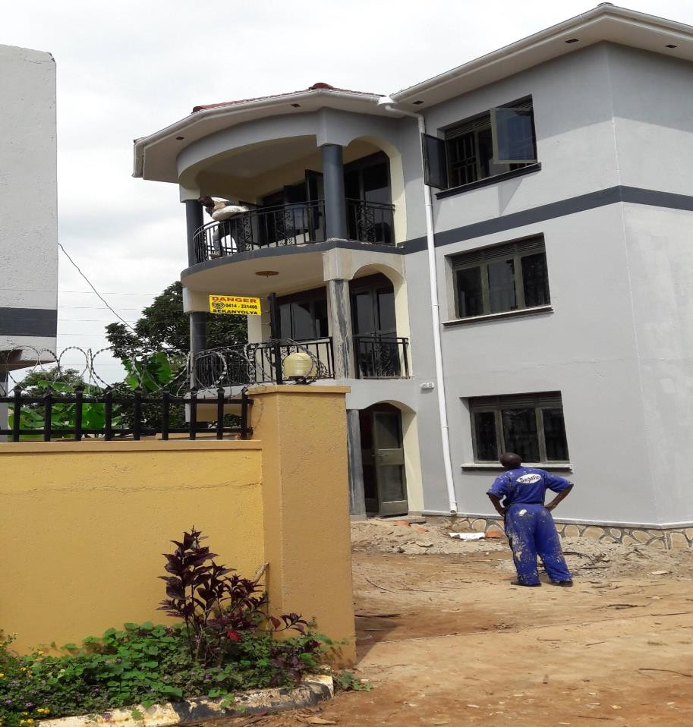

FOR

Linear Engineering Services Ltd
Engineers & Planners
Plot 895 Nsasa Road, P. O Box 120060, Kampala, Tel: +256-772- 588031 / 0414 670373
Email: info@linearengineering.ug lsstone2010@gmail.com

Website: www. linearengineering.ug

2026

PROFILE CONTENTS

1.0 | Company brief Introduction
2.0 | Scope of Services and types of projects
5.0 | Selected projects
6.0 | Evidence of completed and ongoing works.

BASIC INFORMATION
1.1 IDENTITY
Registered name: | Linear Engineering Services Ltd
Certificate of Incorporation/ Date of Registration | 30/01/2018
Tax Identification No: | 1012561408
Company Registration NO: | 80020000635988
NSSF Company No: | NS125350VOL
Full Names of Representative | Livingstone Seruyange Kato
1.2 ADDRESS:
Plot 895 Nsasa Road,
P. O. Box 120060, Kampala,
Tel: +256-772- 588031 / 0414 670373
Email: info@linearengineering.ug
Lsstone2010@gmail.com
Area of Specialization | Building, Civil and Structural Engineering Works,  Electro-Mechanical Engineering Building Services, IT and Security System/ Equipment.
Practice | Founded and established in 2018
Bankers | - DFCU Bank Limited, Lugogo Branch Plot 2-8, Lugogo By-Pass  Shoprite Lugogo  - Opportunity Bank Uganda Limited Plot 1259, Old Kira Road Kampala
Auditors | Evlo and Company Certified Public Accountants  P.O. Box 26689 Kampala, Uganda.

COMPANY OVERVIEW

Linear Engineering Services Limited (LESL) stands as a distinguished general building construction company, renowned for its accumulated expertise, unwavering commitment to quality, and efficient project management. Despite its youth, Linear Engineering possesses the capacity and capabilities to undertake and excel in large-scale projects, owing to the seasoned leadership of Mr. Seruyange Livingstone, the esteemed Managing Director, who brings extensive experience in the engineering field.
Mr. Livingstone's portfolio includes a diverse array of notable projects, such as the supervision of the Terrewode Women Community Hospital in Soroti—a dedicated facility for Fistula repairs in Uganda—and the construction of Community Halls and Modern Market Stalls in Hoima, aimed at supporting individuals affected by the construction of Kabale Airport. Remarkable endeavors also include the establishment of an Operating Theatre in Nakasongola, funded by the OOR BAIRNS CHARITABLE TRUST of Scotland, as well as various projects involving Government Schools, Community Access Roads, Private establishments and the implementation of the Street Surveillance Camera System in Kampala, Munyonyo, and Entebbe during the Commonwealth Heads of Government Meeting (CHOGM). Additionally, Mr. Livingstone contributed significantly to the provision of weak current at the UN Regional Service Centre in Entebbe, while serving at senior management levels with industry leaders.
Incorporated in Uganda on January 30th, 2018, Linear Engineering specializes in Construction and Civil Engineering projects, offering both traditional general contracting services and comprehensive construction management solutions. Recognizing the uniqueness of every client, we tailor our services to meet individual needs, goals, and budgetary constraints, thereby enhancing the value and success of each project we undertake. Our unwavering commitment to quality, cost-effectiveness, efficiency, and professionalism guides our approach, ensuring timely completion and adherence to budgetary constraints.
At Linear Engineering, we strive for excellence in every endeavor, leveraging our expertise, dedication, and innovative solutions to deliver unparalleled results and exceed client expectations.
The Firm boasts a seasoned and highly qualified staff complemented by comprehensive office facilities, equipping us with the necessary capacity to seamlessly execute projects within our areas of expertise. Conveniently located at Plot 895 Nsasa Road, Kira Town Council, Wakiso District, our office serves as a hub of productivity and innovation, facilitating effective and efficient project management from inception to completion.

ORGANISATION CHART

LINEAR ENGINEERING SERVICES LTD.
ORGANISATION CHART
Managing Director

Project Manager
Sales & Marketing
General Manager
Admin/ Human Resources

Finance & Accounting Dept.
Finance Director
Operations Manager
Safety & site Supervisor

Office Manager

Field Staff

  - Company Mission
To be a premier provider of affordable, environmentally friendly services, consistently delivered with accuracy and unwavering quality.

    - Vision
To set the standard as a model firm, deeply committed to service excellence and sustainable growth.

    - Health and Safety
At Linear Engineering, the health, safety, and welfare of all individuals involved in our projects—be they staff, subcontractors, clients, or visitors—are of paramount importance. We are steadfast in our pursuit of excellence in health and safety management across all construction sites under our purview. Committed to upholding legal requirements, industry standards, and best practices, we foster a culture of safety within the civil construction sector.

    - Environmental Sustainability
Recognizing that environmental sustainability is a shared responsibility, Linear Engineering embraces its role as a leading local entity committed to environmental stewardship. We understand that environmental consciousness is not only socially responsible but also integral to sound business practice and the enhancement of our esteemed reputation. Therefore, we ensure the rigorous implementation of our environmental policy across all aspects of our operations, striving to minimize our ecological footprint and promote sustainable practices within our industry and beyond.

  - SCOPE OF SERVICES AND TYPES OF PROJECTS
Linear Engineering excels across a diverse spectrum of construction domains, encompassing commercial and residential developments, public institutions such as schools and hospitals, road infrastructure, water and sanitation projects, civil engineering endeavors, and warehouse constructions. Our extensive experience in these sectors is underscored by a robust client base comprised of industry leaders who entrust us to deliver exceptional results.
Our core competencies include:

- Civil and Structural Engineering: We specialize in the design and implementation of robust civil and structural solutions that ensure the integrity and longevity of built environments.

- Joinery & Interior Refurbishments: With a keen eye for detail and craftsmanship, we breathe new life into interiors through expert joinery and refurbishment services, enhancing both aesthetics and functionality.

- Mechanical and Electrical Engineering: Our proficiency in mechanical and electrical systems ensures the seamless integration of essential infrastructure components, guaranteeing optimal performance and efficiency.

- Turnkey Projects and Warehouses: From concept to completion, we offer turnkey solutions tailored to meet the unique requirements of warehouse facilities, delivering projects characterized by functionality, durability, and cost-effectiveness.

- Security Systems/Equipment: Leveraging cutting-edge technology and industry best practices, we provide comprehensive security solutions and equipment installations designed to safeguard assets and personnel effectively.
At Linear Engineering, our commitment to excellence drives us to continually innovate and adapt to evolving industry standards, ensuring the success of every project we undertake.

CLIENTS

Our clientele represents a broad spectrum of the public, encompassing various entities including:
- Government Ministries
- Development Aid Agencies
- Commercial Institutions
- Municipal Authorities and Parastatals
- Private Institutions
- Private Sector Investors

From government ministries seeking infrastructure development to development aid agencies supporting community projects, from commercial institutions expanding their operations to municipal authorities enhancing urban infrastructure, and from private institutions seeking facility upgrades to private sector investors investing in real estate ventures, our services cater to diverse needs and aspirations across the public domain.

Our team of qualified and experienced professionals oversees a comprehensive range of services, including:
- Masonry Works
- Carpentry and Joinery
- Mechanical and Electrical Installations
- Steel Fabrication
- Asphalt and Bituminous Works
- Terrazzo, Wood, Parquet, and PVC Flooring
- Road and Parking Infrastructure
- IT and Security Systems/Equipment
With expertise spanning across these disciplines, we ensure meticulous attention to detail and adherence to the highest standards of quality and craftsmanship in every aspect of our projects.

.0 SELECTED PROJECTS AND COSTS BY LINEAR ENGINEERING SERVICES LTD.

Completed  Date | Project | Status
October 2025 | Construction of a maternity complex at Nakasongola HCIV in Nakasongola District. | Completed
August 2025 | Drainage Improvement Works on Sekajja, Oketcho and Hajjat Bilabwa Community Drains in Kitintale, Nakawa | Completed
March 2025 | Drainage Improvement of Tomato Sauce Community in Nakawa Division | Completed
July 2024 | Drainage Improvement of Alipo Drainage-Mutungo (Mbuya) | Completed
January 2024 | Rehabiliation of Kabalungi-Butenja road (7.6km) in Kakumiro District. | Completed
January 2023 | Construc Construction of Two Residential Houses in Soroti City. | Completed
January 2023 | Construction of a staff house at Kalege HC III in Semuto Sub-County, Nakaseke District. | Completed
August 2022 | Construction of Community Centre & Market Stalls at Kyakaboga Resettlement Village, Hoima District;  for Ministry of Energy and Mineral Development. | Completed
August 2022 | Construction of Surgical block at Nabiswera HCIV. | Completed
April 2022 | Rehabilitation of Kasenge-Mukunja, Kisaalita, Girinya- Kitagayika-Nakibano, Kiwafu-Nakigudo and Kayanja-Kalagala roads (11.15Km) in Mukono  District | Completed
June 2021 | Phase 2 Construction of Kalaki District Administration Block (Storied) | Completed
May 2021  2020 | Construction of 2 Classroom Block at Kyanika and Kiranga Primary Schools  Nakasongola District | Completed
June 2020 | Phase1 Construction of Kalaki District Administration Block (Storeyed) | Completed
July 2020 | Rehabilitation of Nyamiranga- Budimbo Road (11.8 KM) in Kiboga District | Completed

June, 2019 | Supply Delivery and Installation of Staff Clock In and Clock Out Machines | Completed
2018/19 | Phase II Construction of Wabinyonyi Seed Secondary School | Completed
June 2019 | Construction of Doctor’s House at Nabiswera H/CIV | Completed
2018 | Supply and installation of Surveillance camera System at TERREWODE Liaison office, at Nsasa, Wakiso district and Soroti Women Community  Hospital | Completed
2018 | Supply and Installation of a waist turn stile at VIVO Energy, contracted By Balton Uganda | Completed

6. 0 Evidence of Completed and Ongoing Works

Drainage Improvement of Alipo Drainage-Mutungo (Mbuya).

Rehabilitation of Kabalungi-Butenja road (7.6km) in Kakumiro District.

Construction of a Staff house at Kalege HC III in Semuto Sub-County, Nakaseke District.

Construction of residential houses in Olimai and Oderai , Soroti District.
      - Construction of Community Centre & Market Stalls at Kyakaboga Resettlement Village, Hoima District; for Ministry of Energy and Mineral Development.
      - Rehabilitation of Kasenge-Mukunja, Kisaalita, Girinya-Kitagayika-Nakibano, Kiwafu-Nakigudo and Kayanja-Kalagala roads (11.15Km) in Mukono District for Ministry of Works and Transport.
      - Construction of Surgical block at Nabiswera HCIV, Nakasongola District.
      - Construction of Kalaki District Administration Block in Kalaki District.
      - Construction Nyamiranga- Budimbo Community Access Road (11.8Km) in Kiboga District.
      - Construction of 2 Classroom Block in Kiranga, Nakasongola District.
      - Renovation of Kanoni HCIII in Ibanda district.
      - Supply of materials for repairing Road (Sub Contracted from Haheh Contractors) –UETCL
      - Wabinyonyi Seed School.
      - Ministry of Local Government.
      - Nabiswera Doctor’s House.
      - Wabinyonyi Electrical Installation.
      - Meera Investments Ltd.
      - Balton Uganda Ltd.

Construction of Community Centre & Market Stalls at Kyakaboga Resettlement Village, Hoima District.

Ground Breaking Ceremony
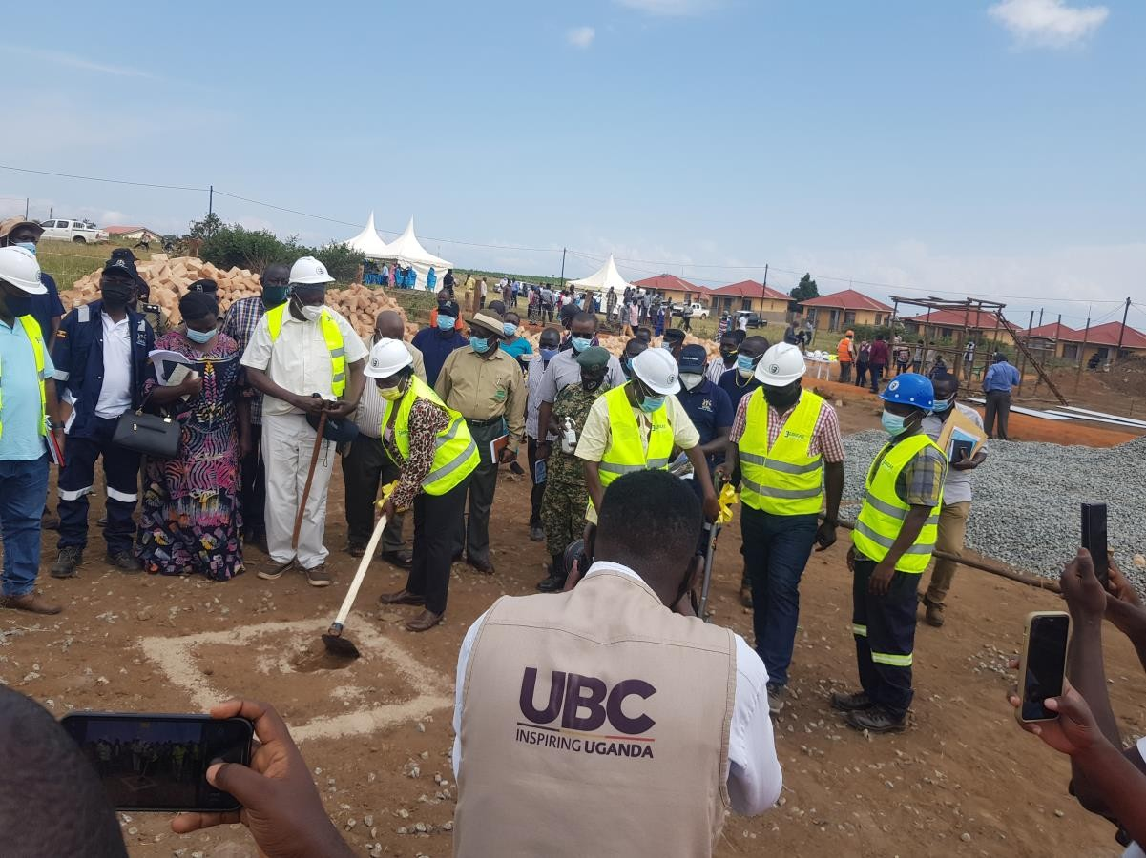
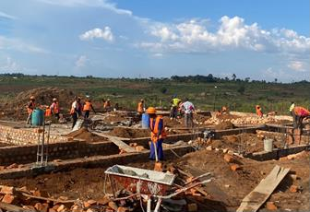
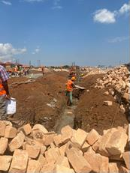

Foundation layout of Community center

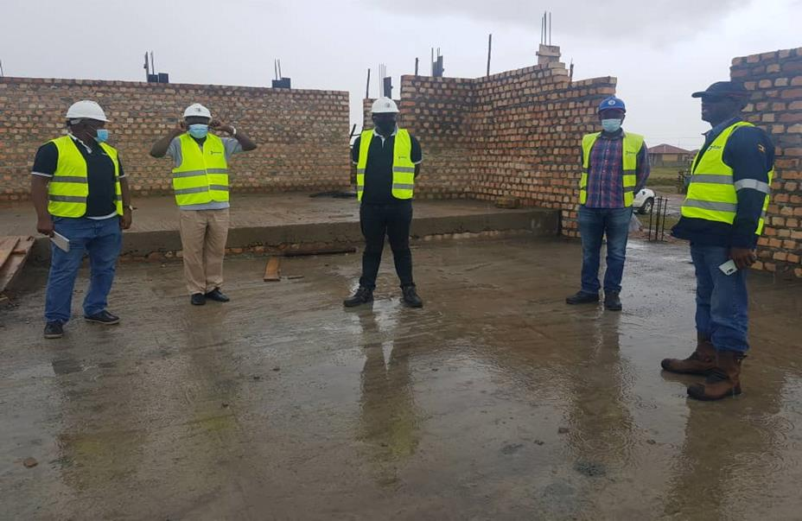
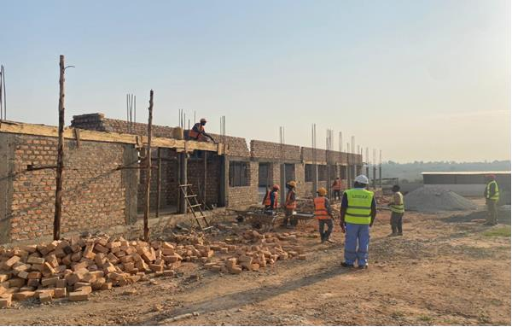

Works in progress

Works In Progress Site Inspection
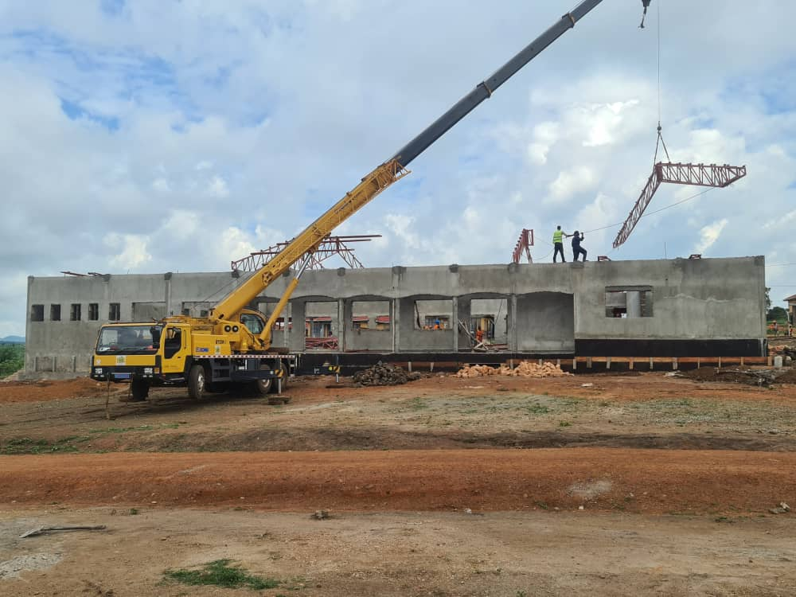
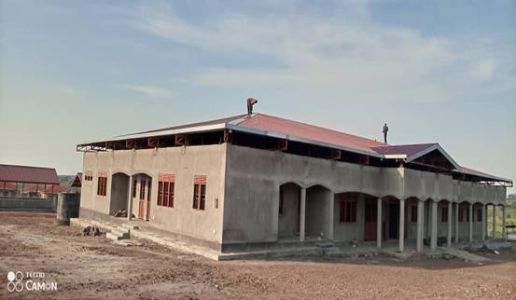

Roofing of community center in progress Front View of the roofed community center

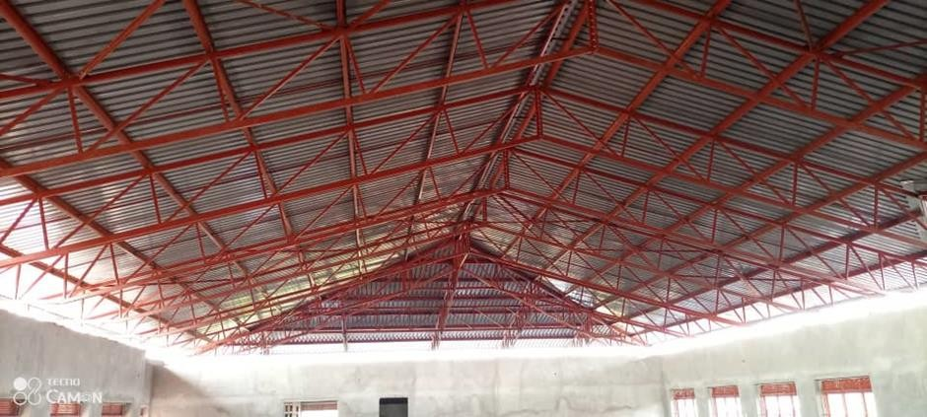
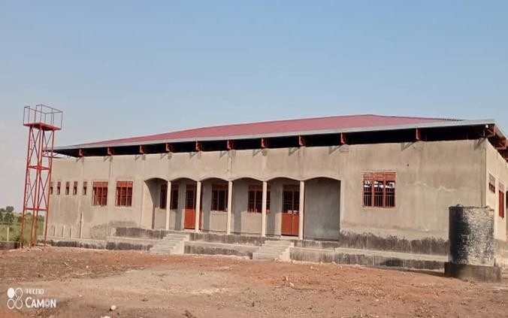

Roof truss (Interior) Rare view of the roofed community center

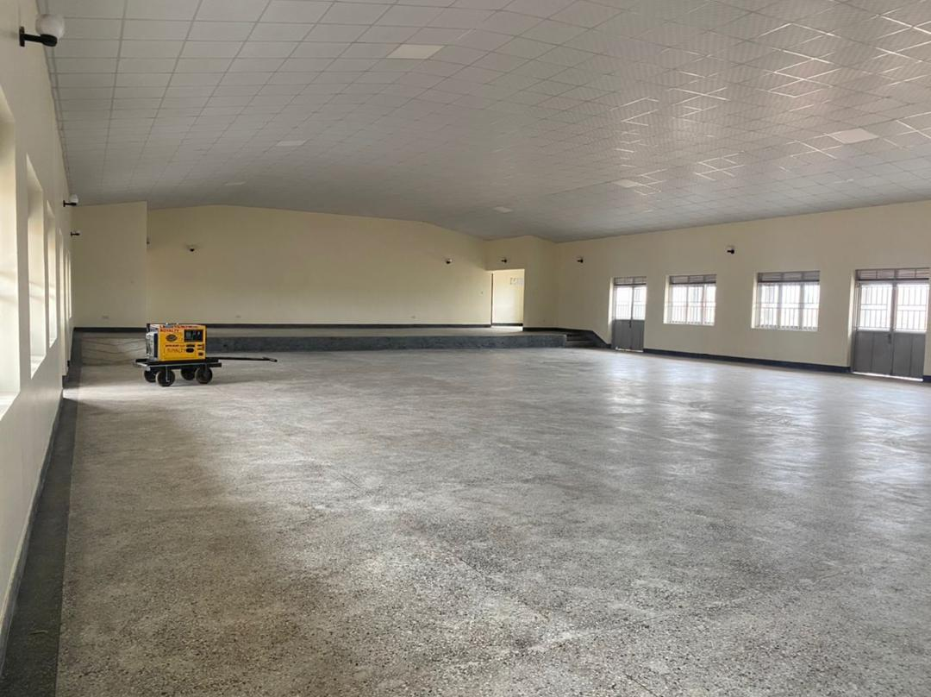
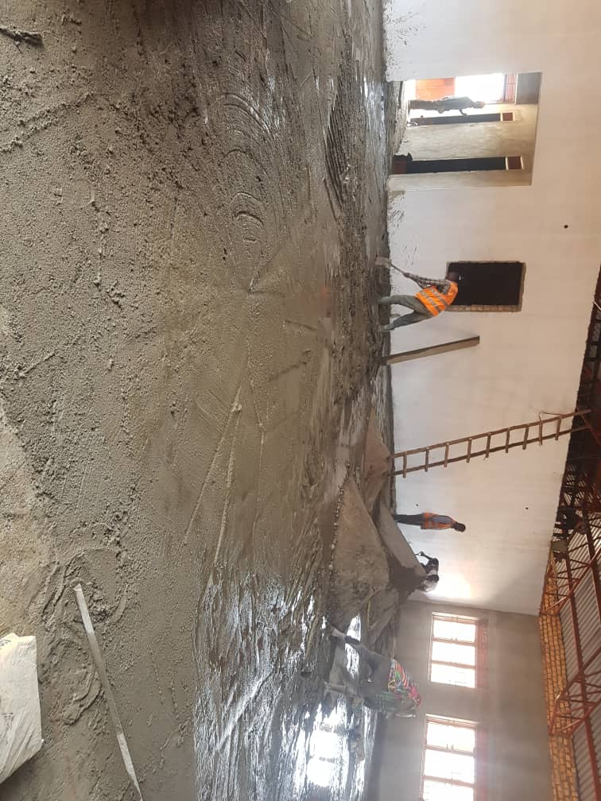

Interior works in progress-Community center Interior view (Completed) of the Community center

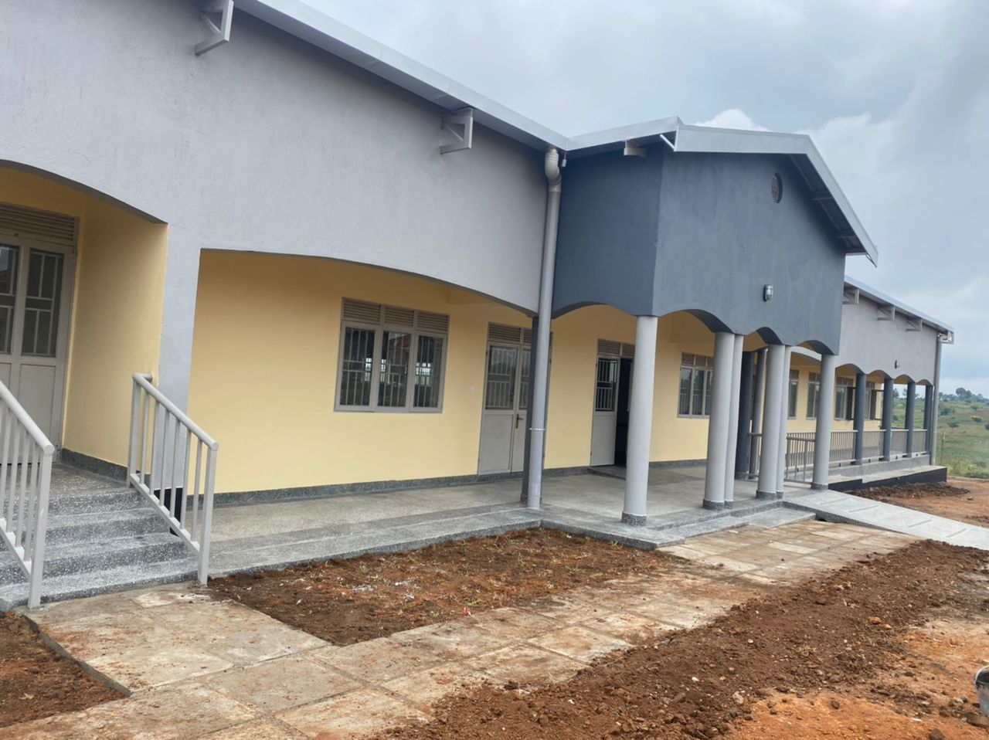
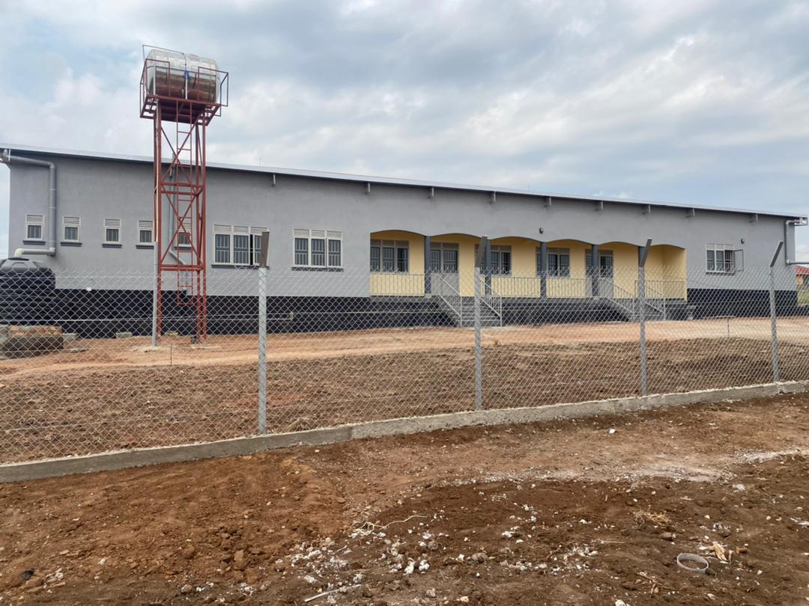

Front view of the community center Rare view of the community center
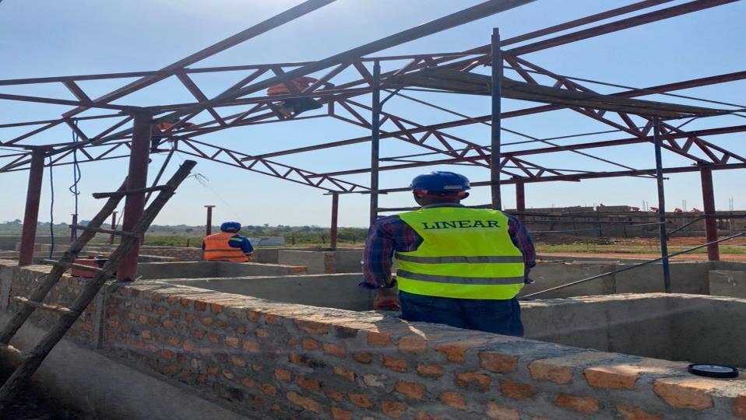
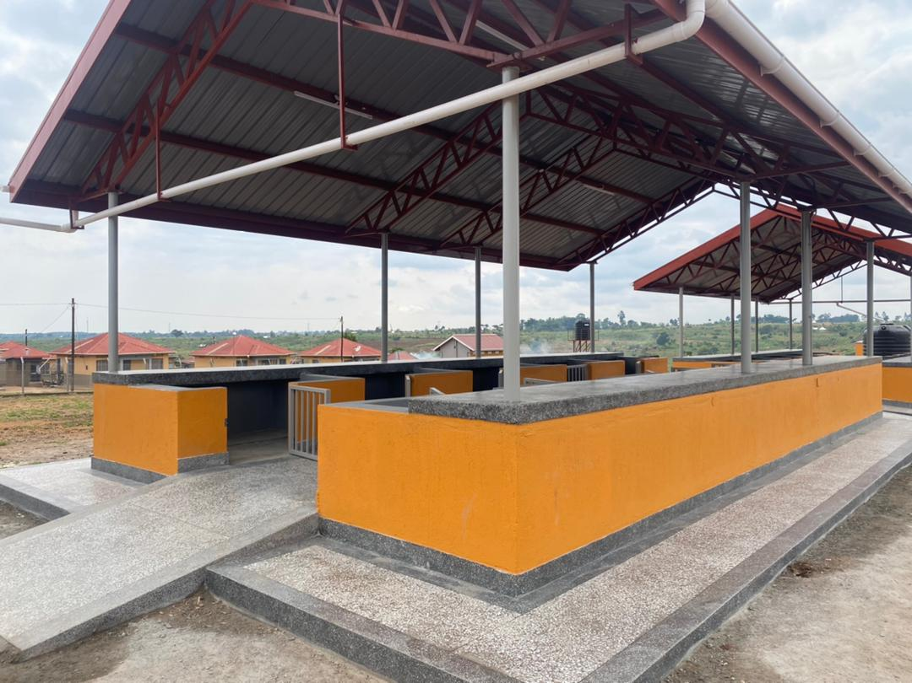

Roofing of market stalls Completed market stalls
Construction of a Staff House at Kalege HCIII in Semuto Sub-County, Nakaseke District.

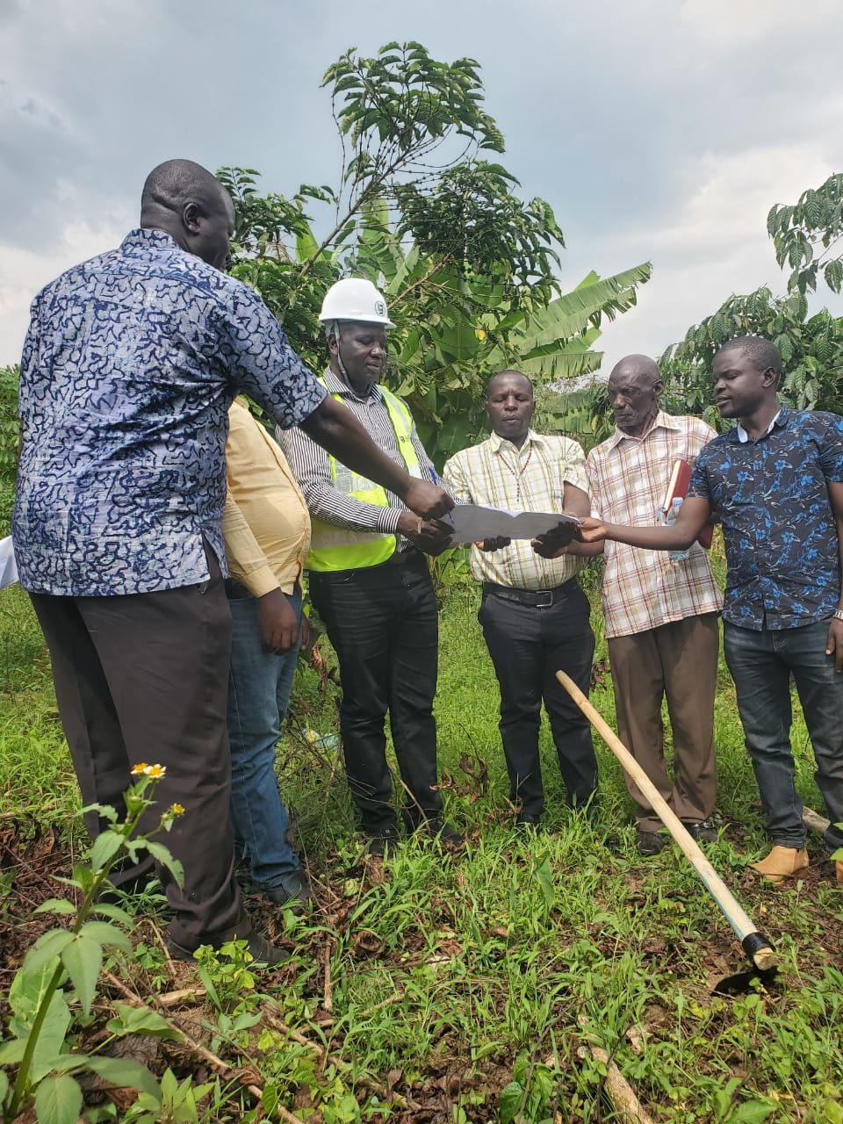
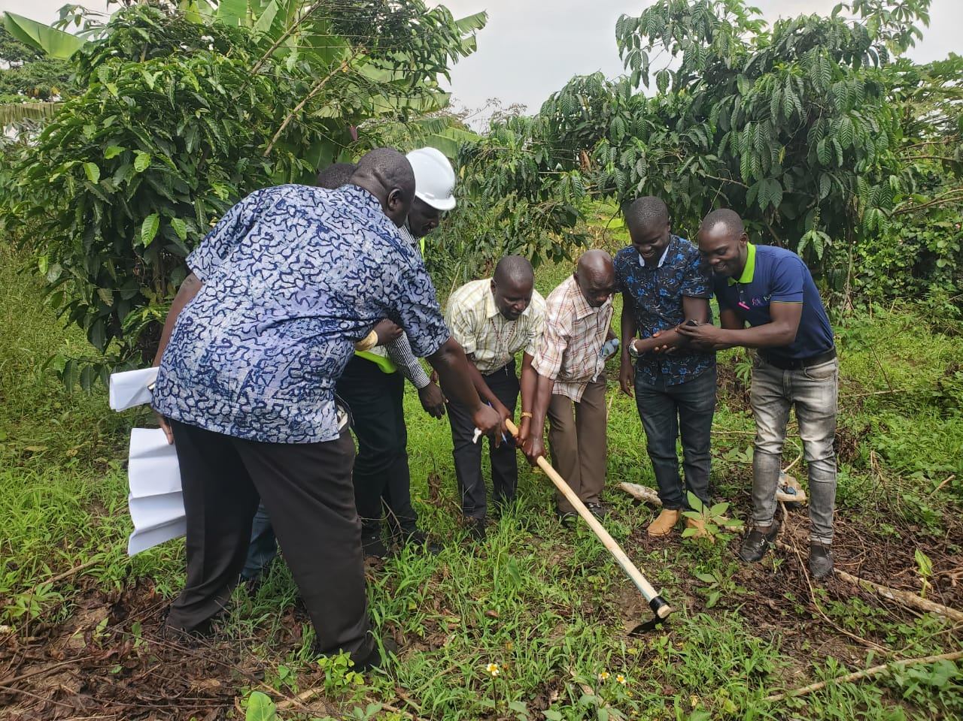

Ground breaking ceremony

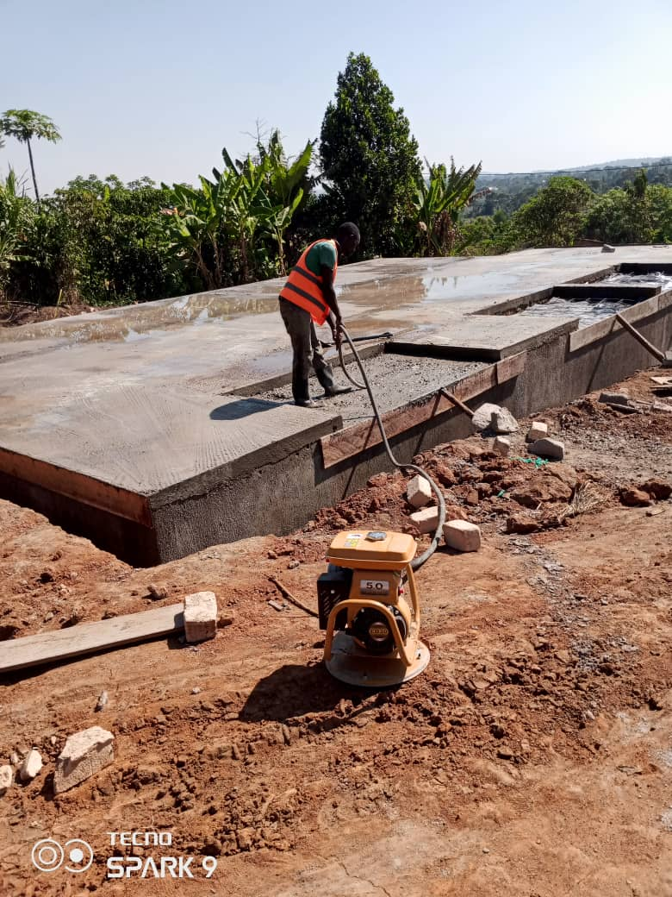
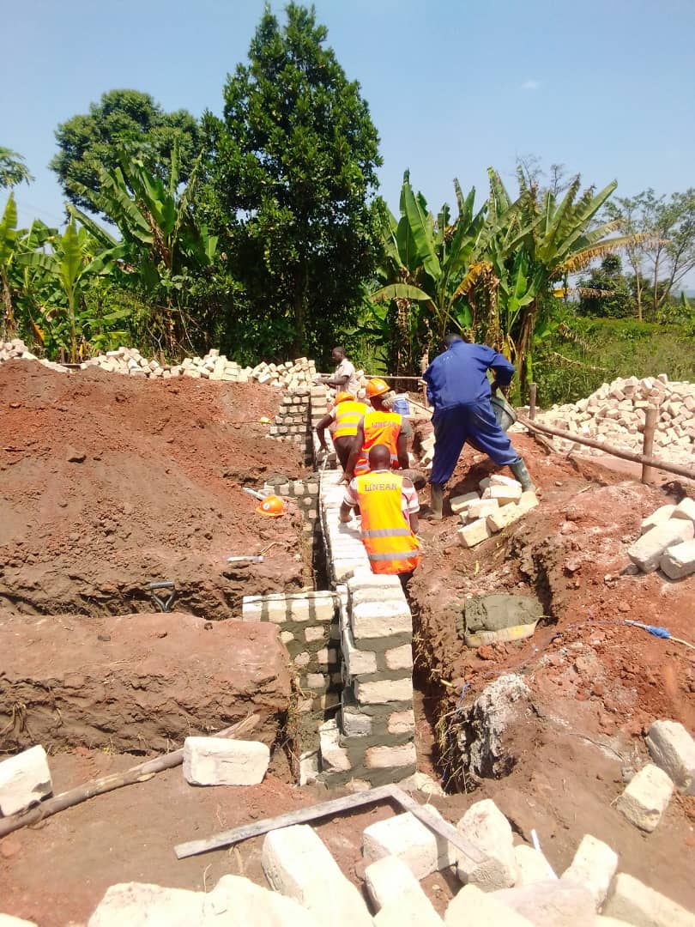

Foundation setup

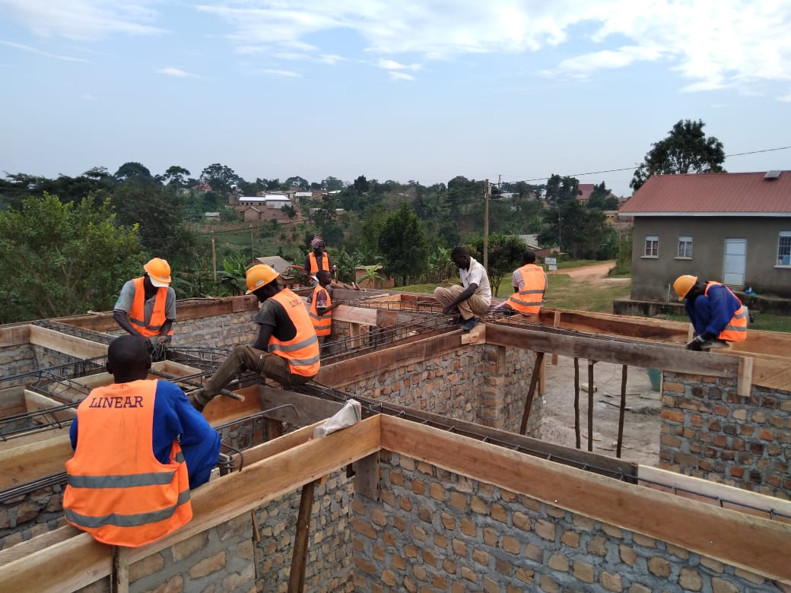
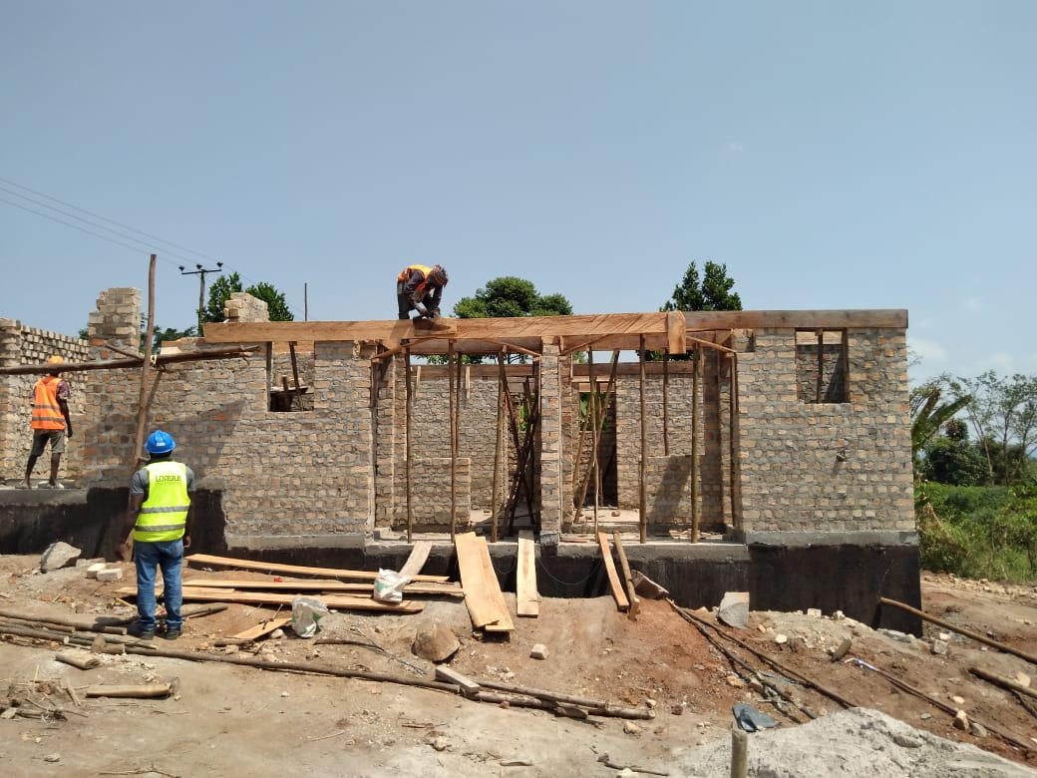

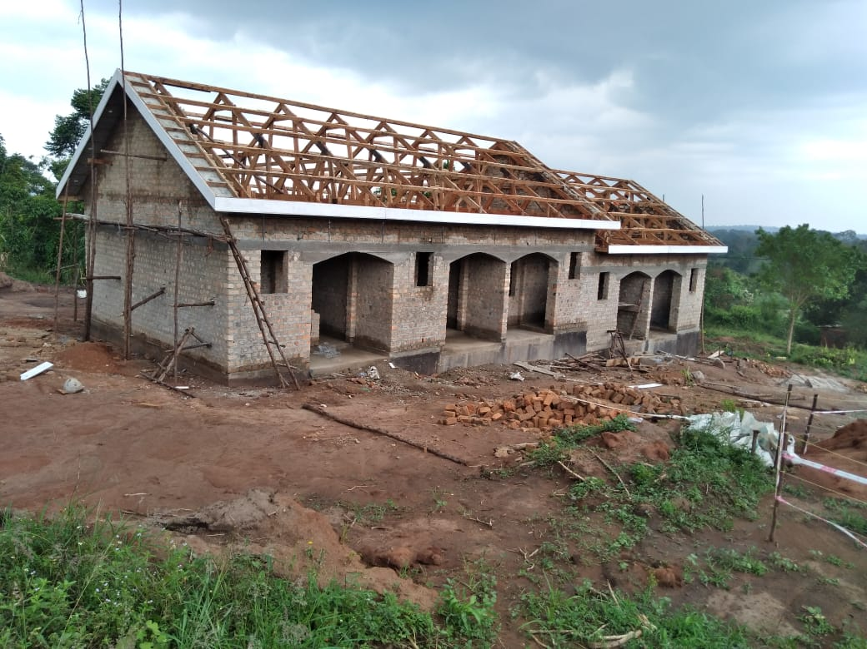
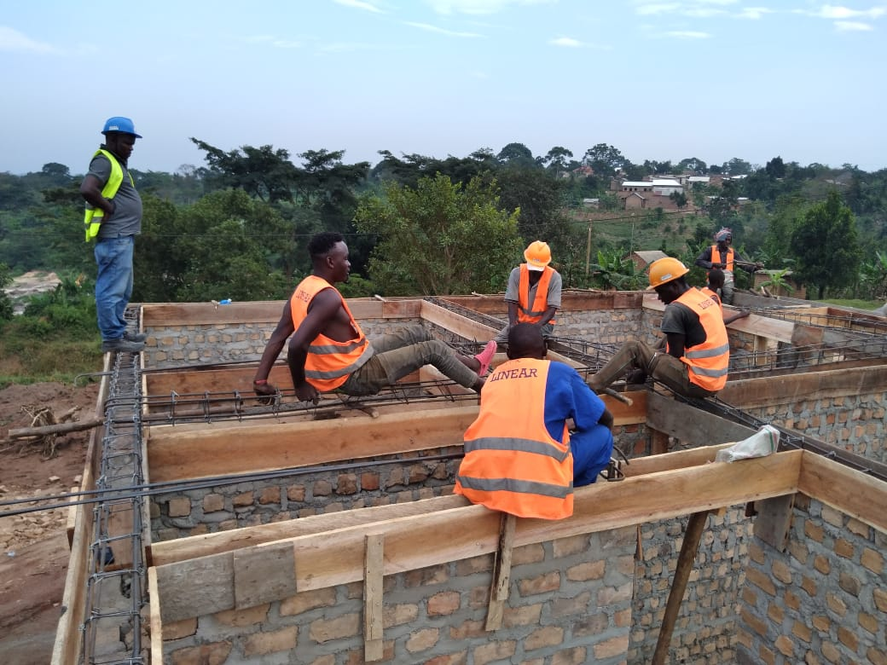

Roofing works in progress

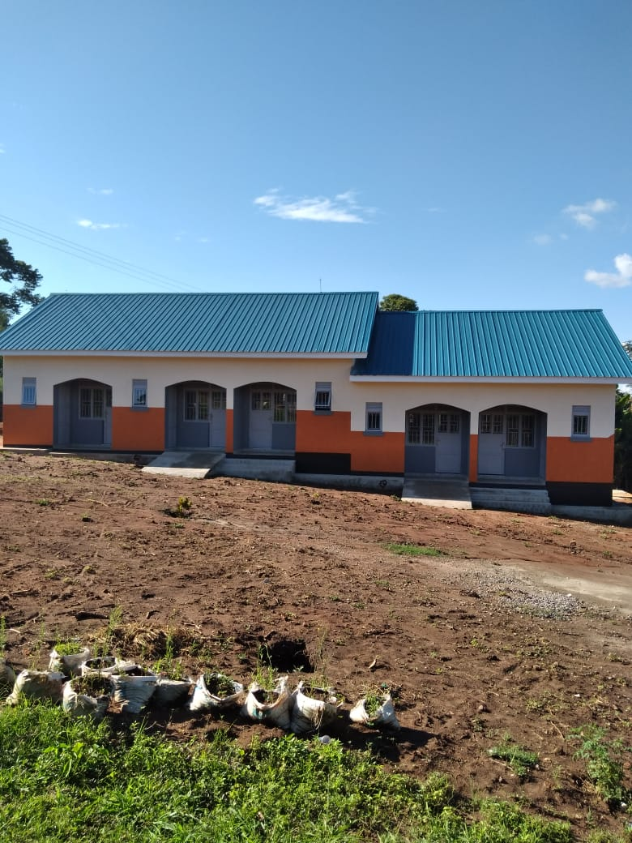
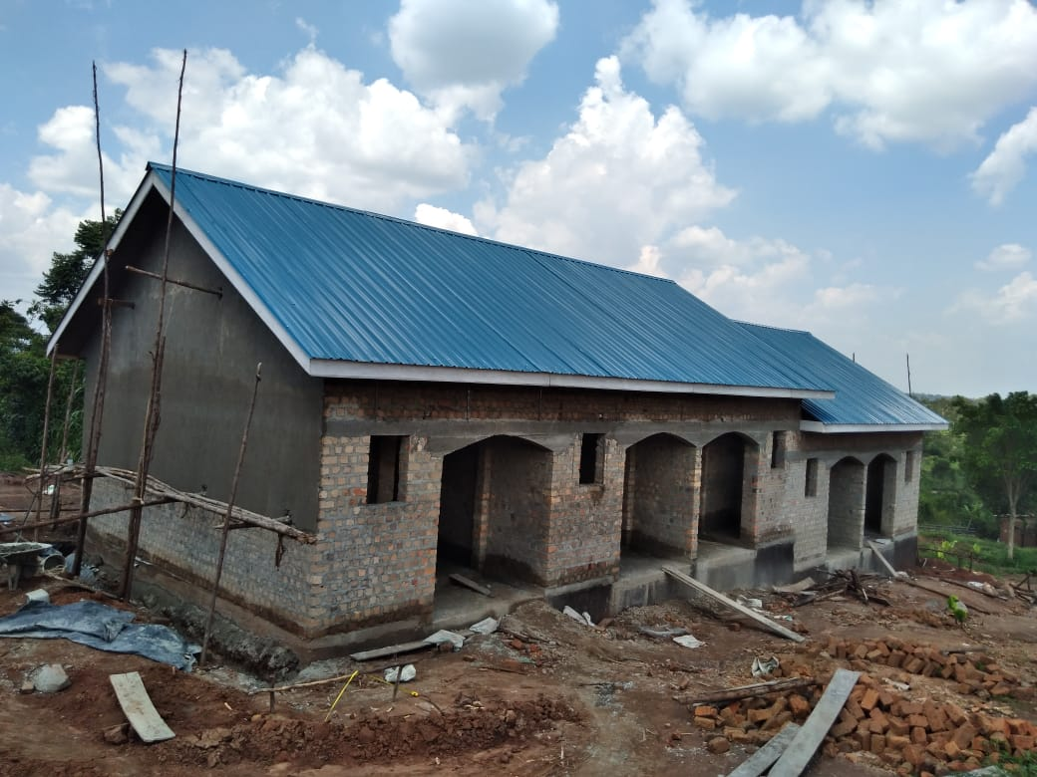

Plastering works in progress Completed Structure

Construction of a Maternity Complex at Nakasongola HCIV in Nakasongola District.
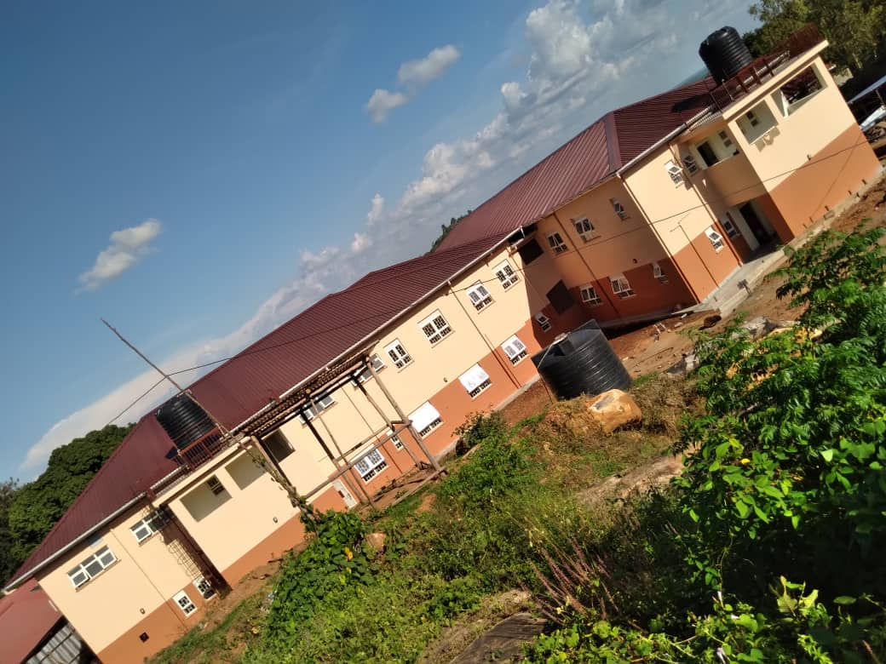
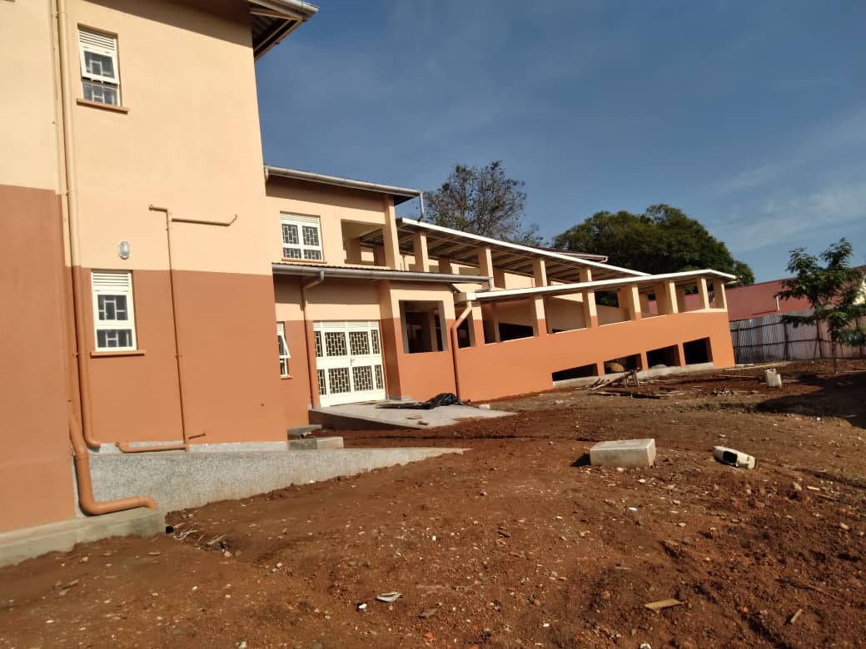
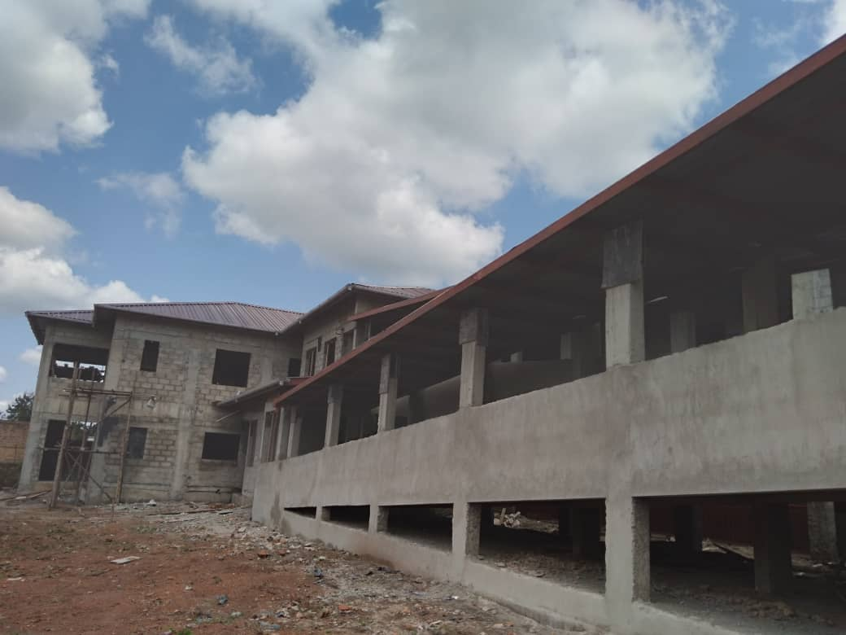
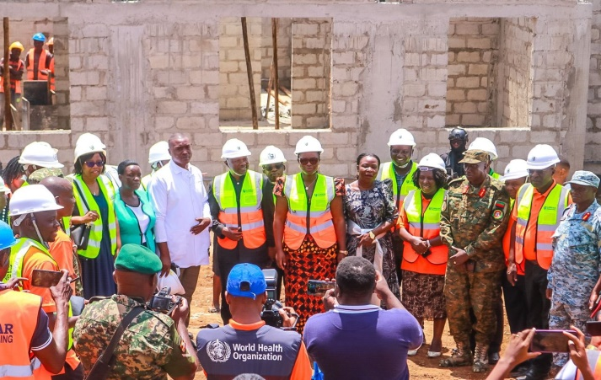
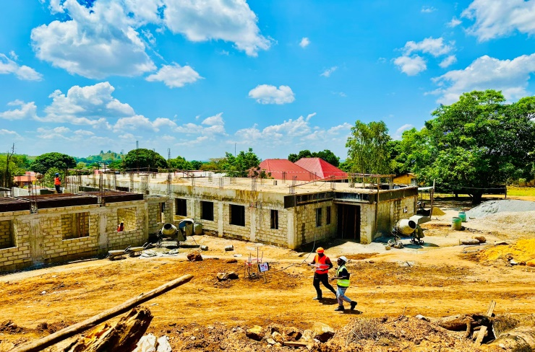
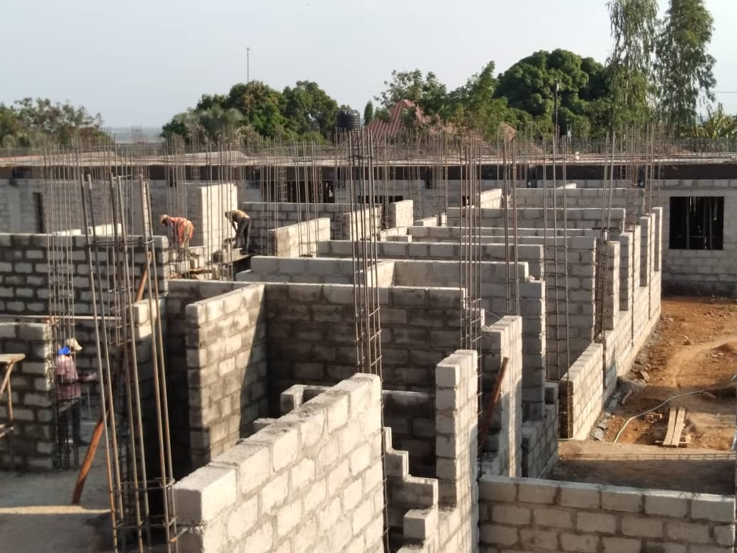
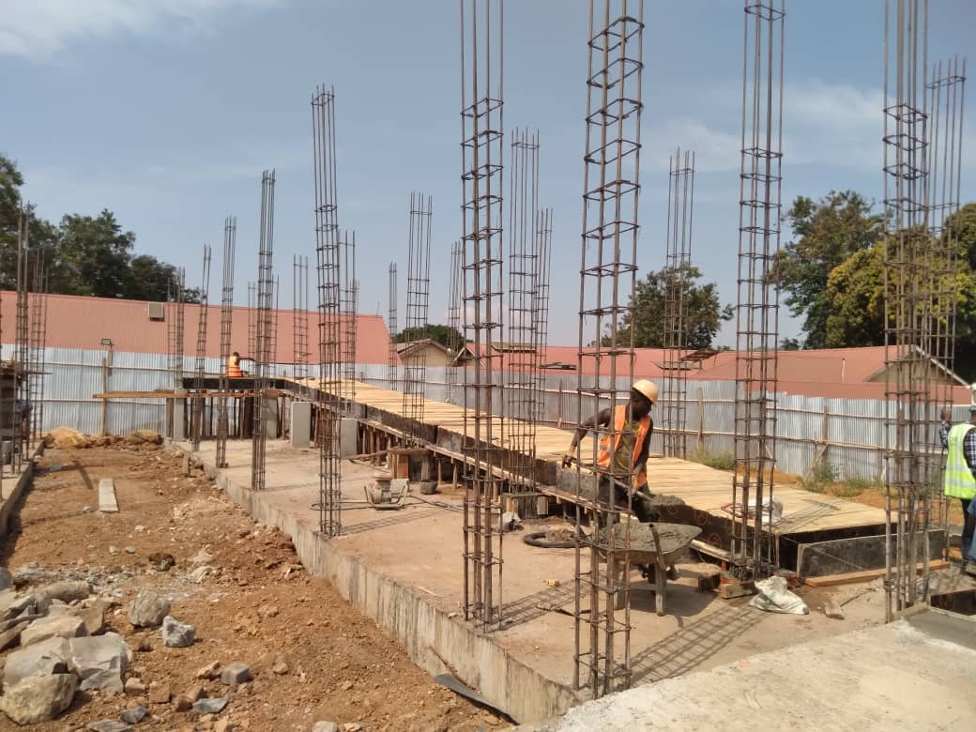
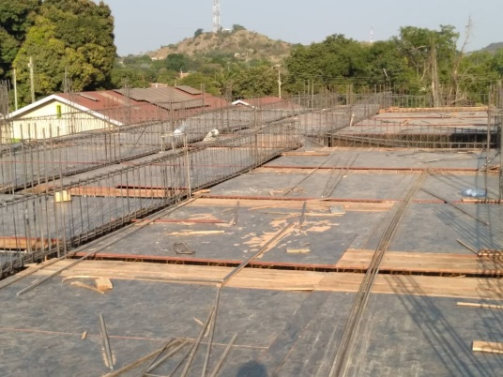
Figure 8 General view
Figure 7 Side view
Figure 6 Plastering in progress
Figure 5 Site visit by Hon. Min. Lillian Aber and team
Figure 4 Slab curing and preparation
Figure 3 Walling works
Figure 2 Ramp slab preparation
Figure 1 Slab preparation
Construction of Surgical Block at Nabiswera HCIV in Nakasongola District.
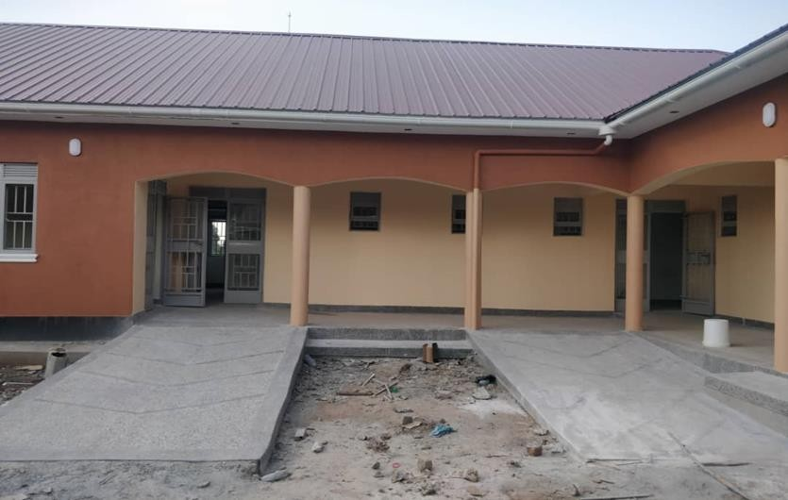
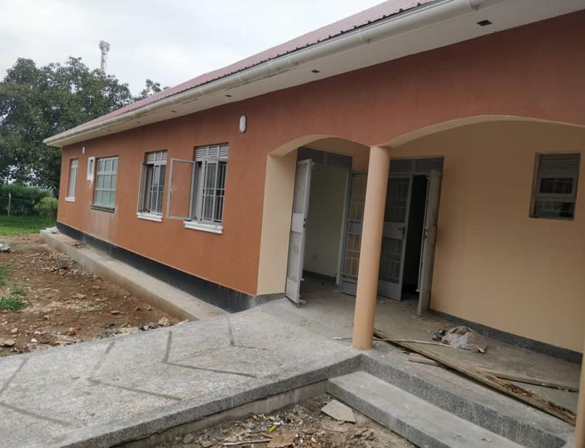

Front view of the surgical block
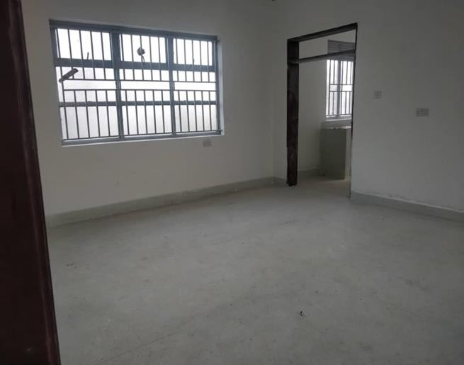
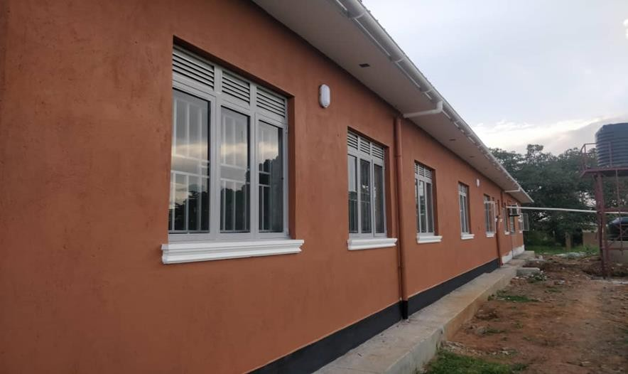

Side view of the surgical block Inside one of the theatre rooms

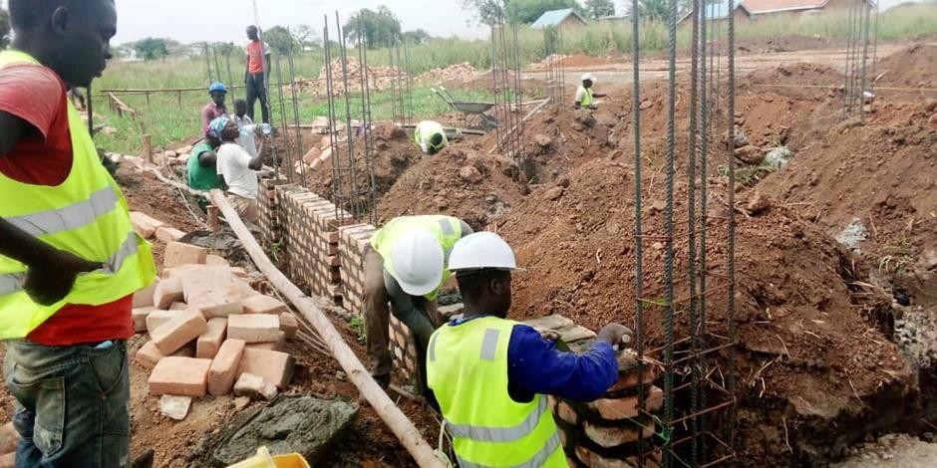
Construction of Kalaki District Administration block-Phase 1&2
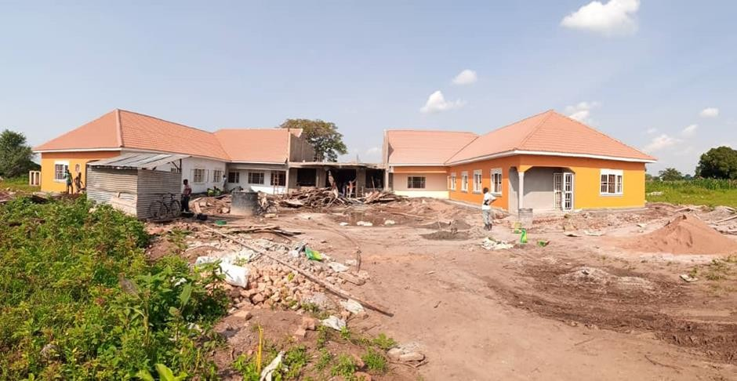
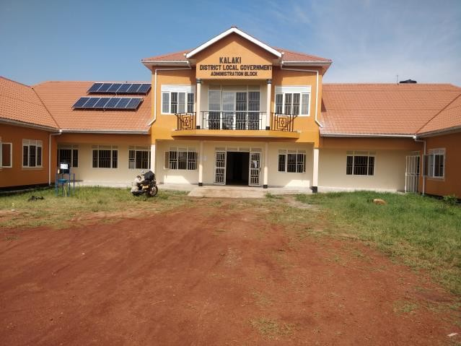
Plinth walling in progress
Figure 3 Completed structure
Figure 1 Works in Progress

Construction of residential houses in Soroti.
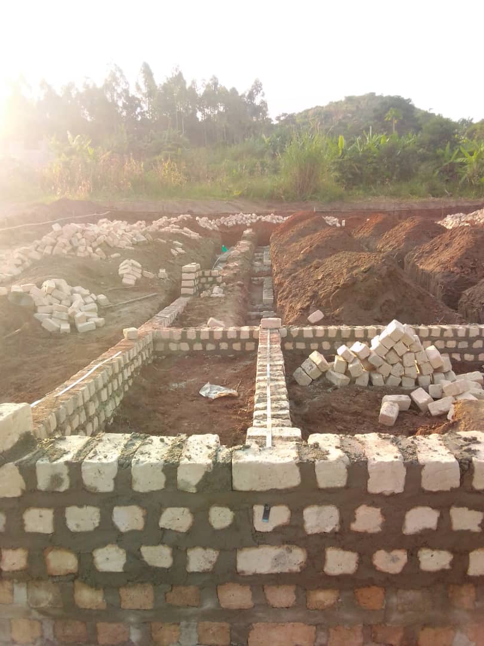
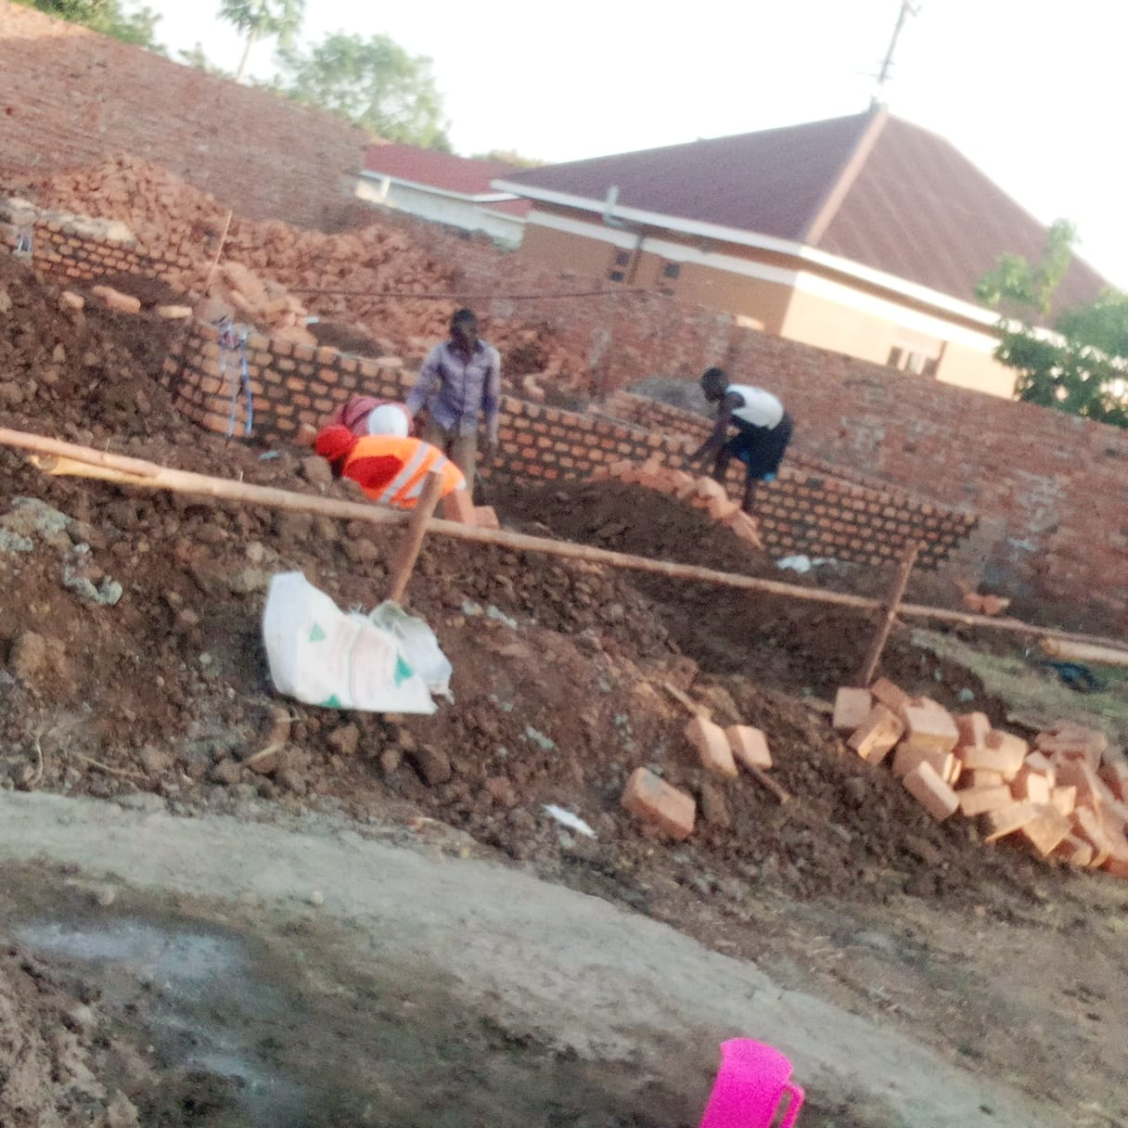

Foundation layout

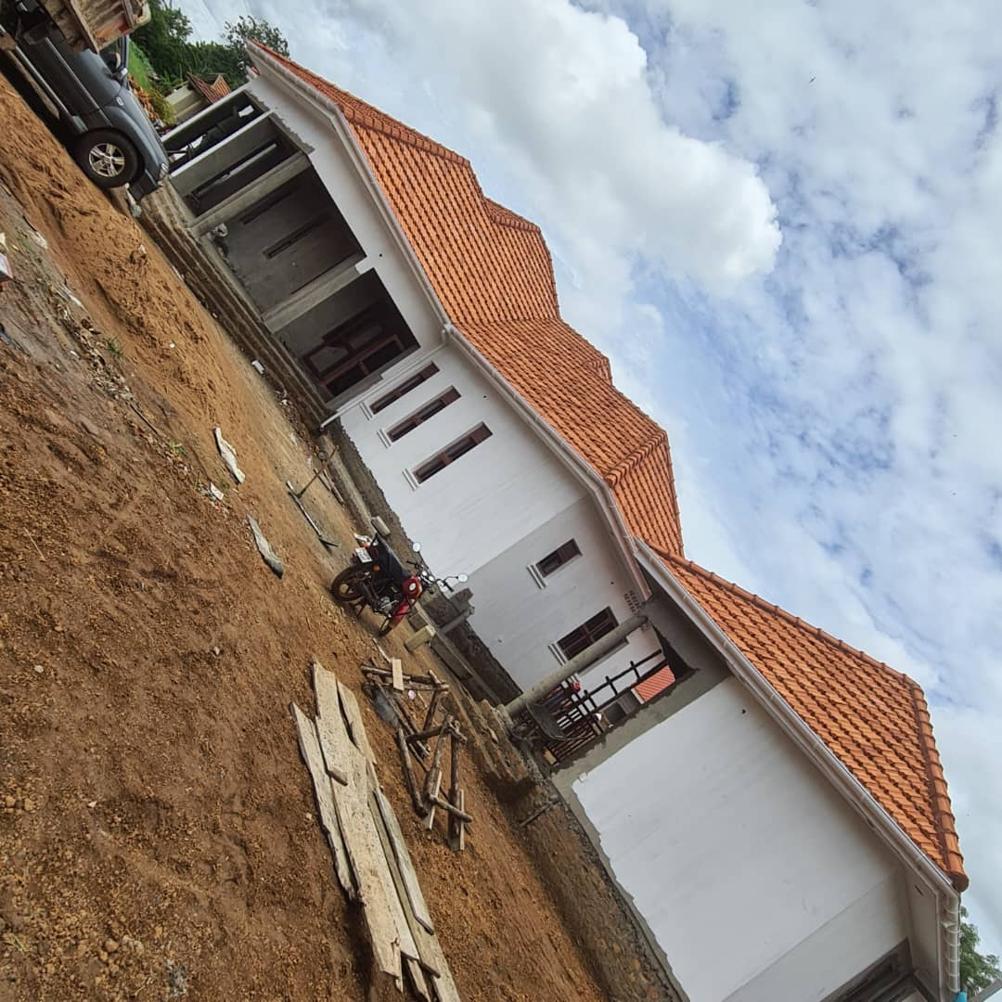
Works in progress
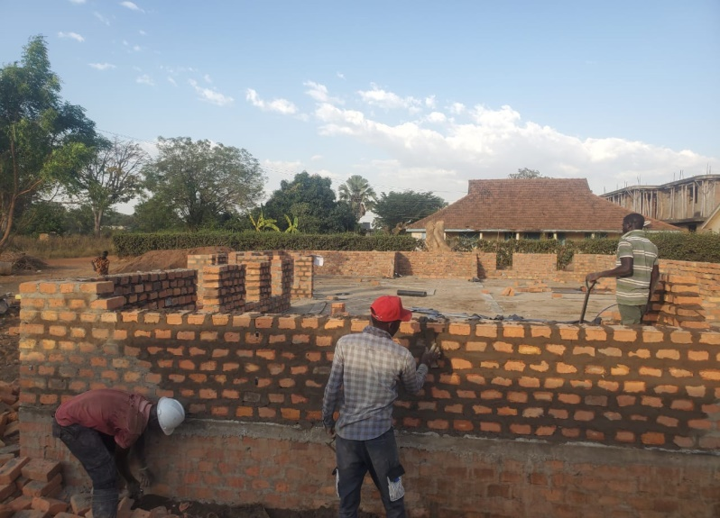
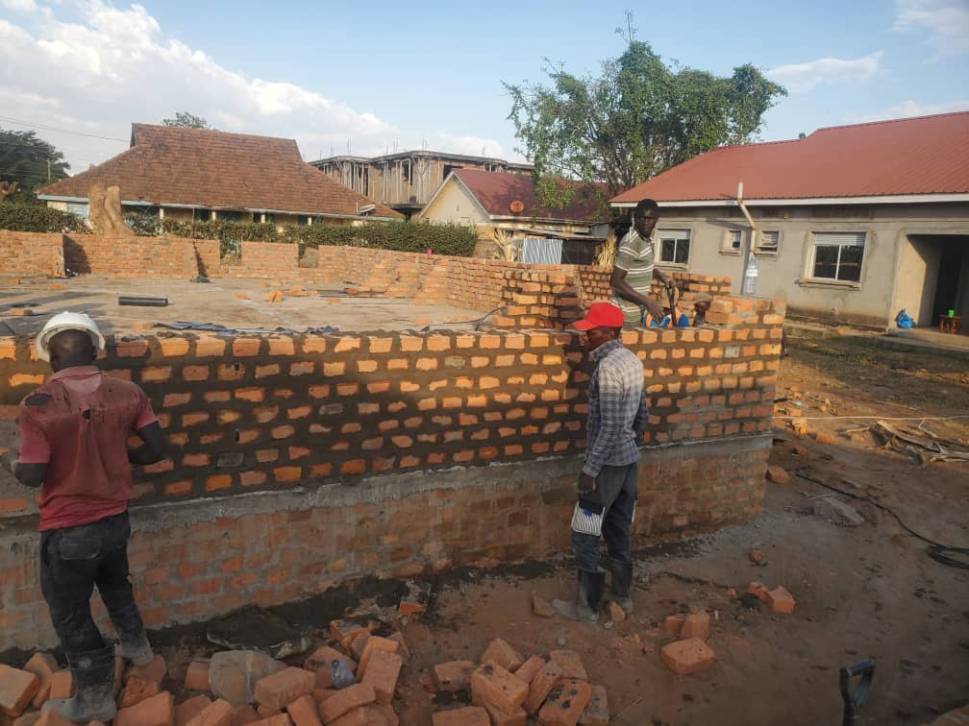
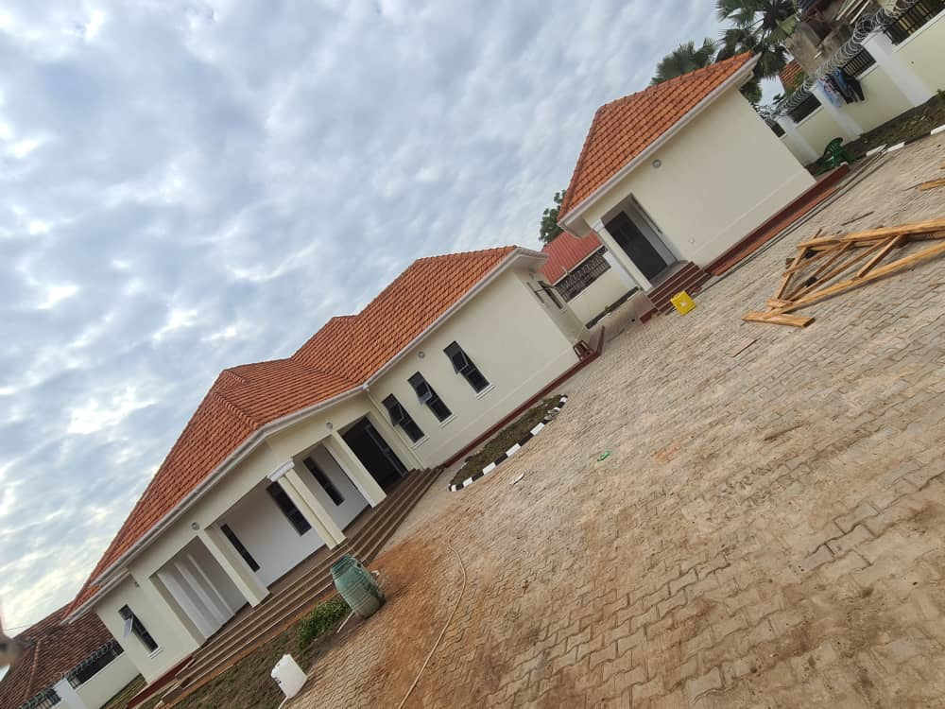

Completed structures

Drainage Improvement of Alipo Drainage-Mutungo (Mbuya).

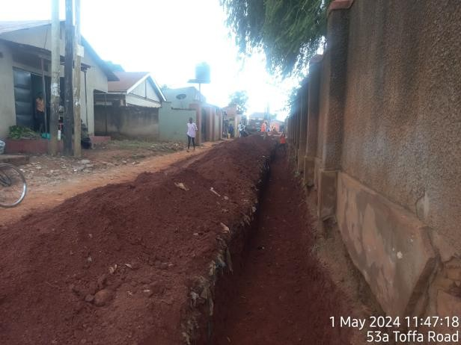  Excavation for Drainage | 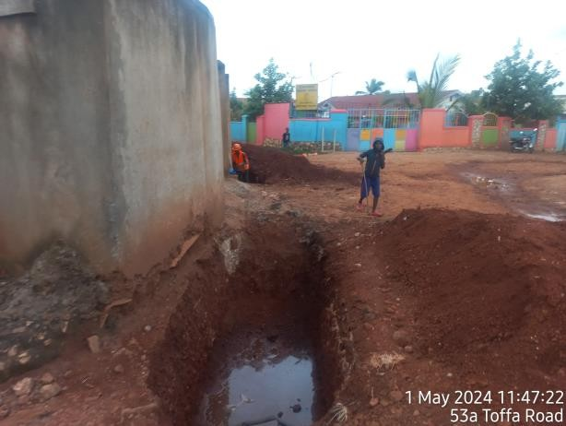  Excavation for drainage
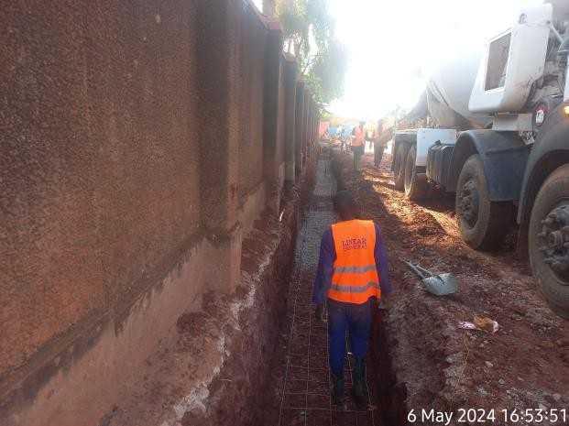  Casting of Reinforced Concrete base  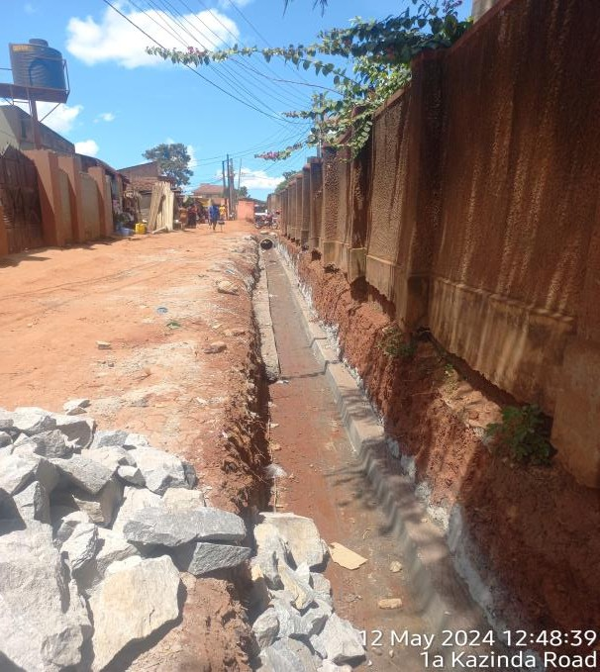  Concrete upstand | 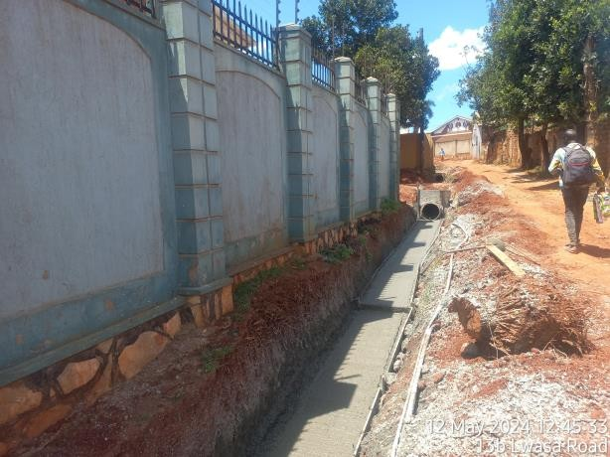  Casting of reinforced concrete base  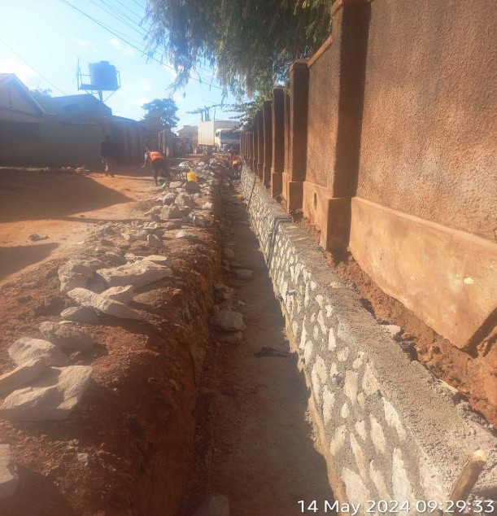  Stone pitching works
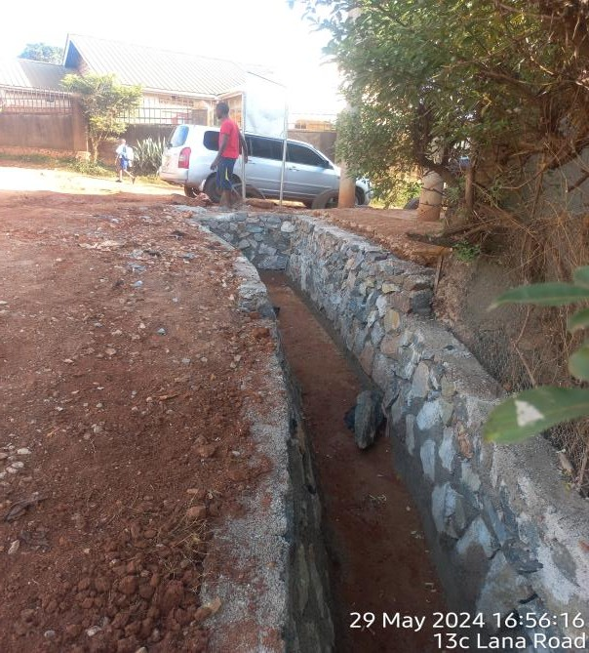  Stone pitching works | 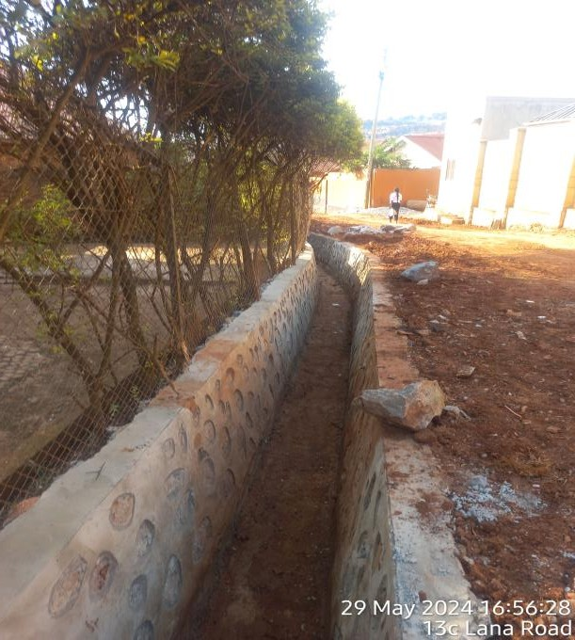  Stone pitching works
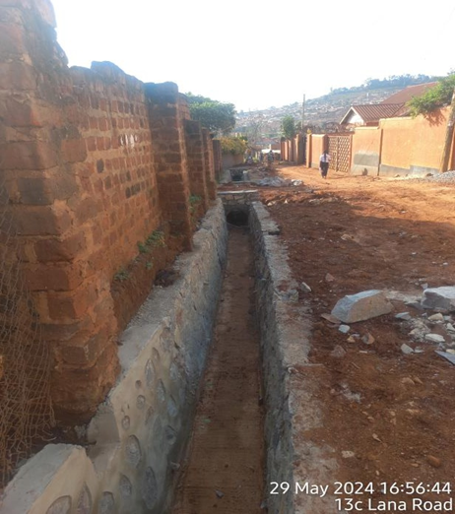  Stone pitching works | 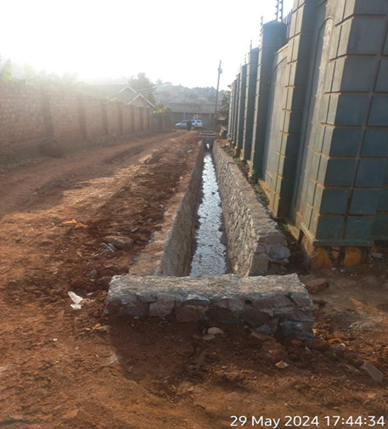  Stone pitching works

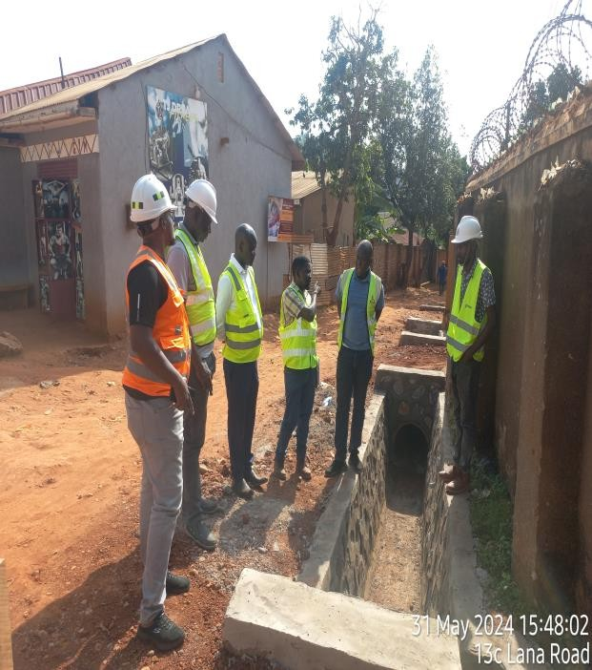  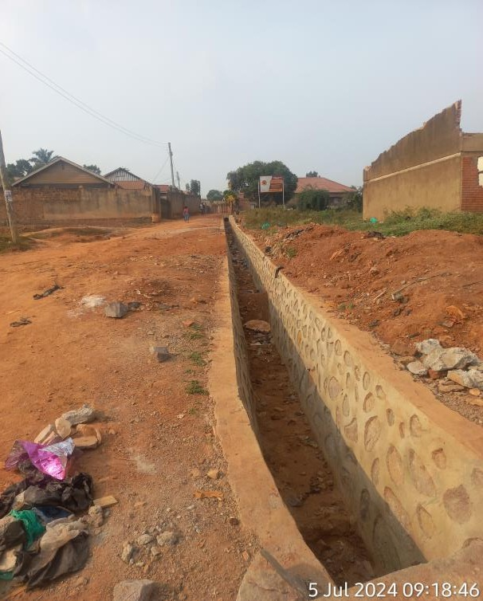  During site inspection  Finished Drainage  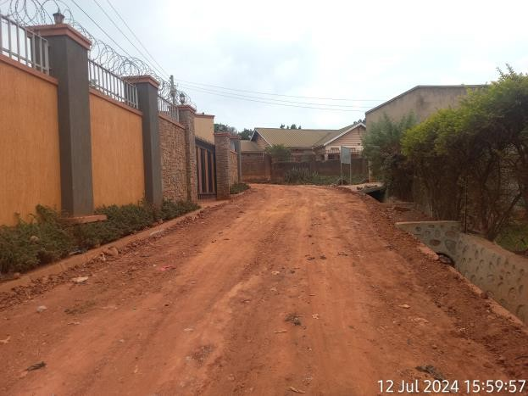  Shaping of the Road after drainage Construction | 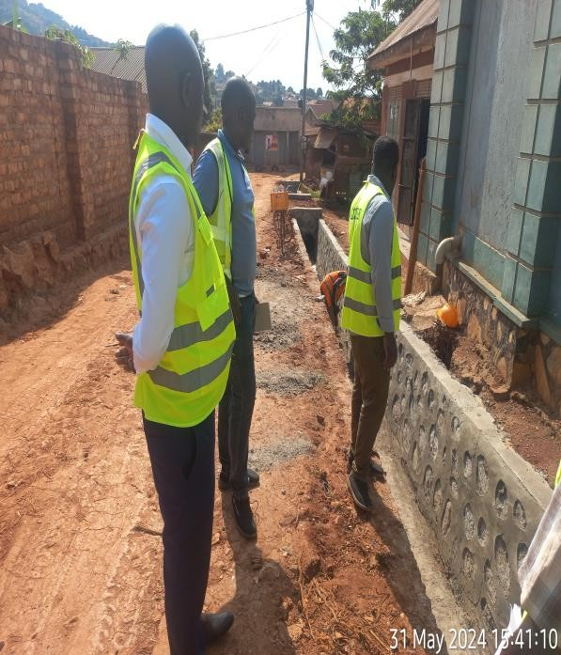  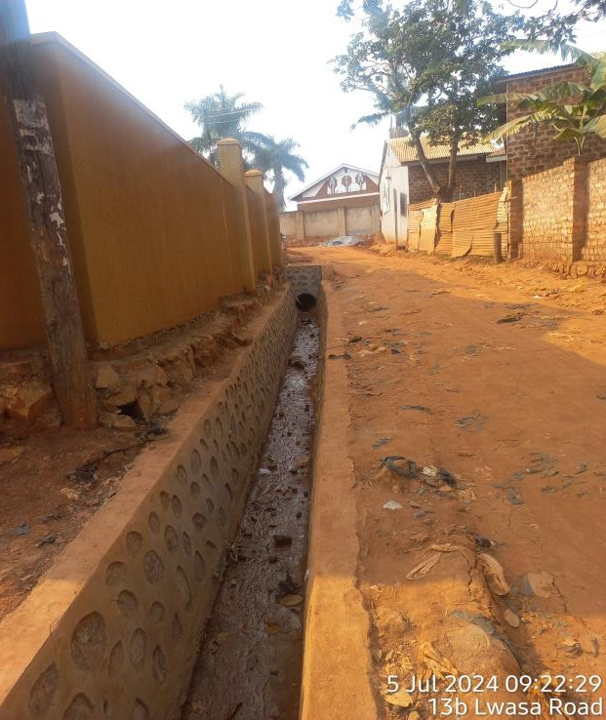  During site inspection  Finished Drainage  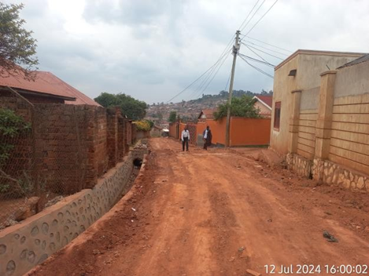  Shaping of the Road after drainage Construction

Rehabilitation of Kabalungi-Butenja Road (7.6km) in Kakumiro District.

Bush clearing Earth works (Swamp)
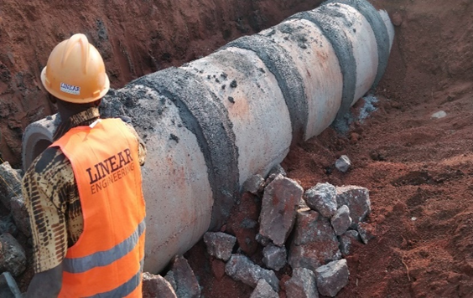
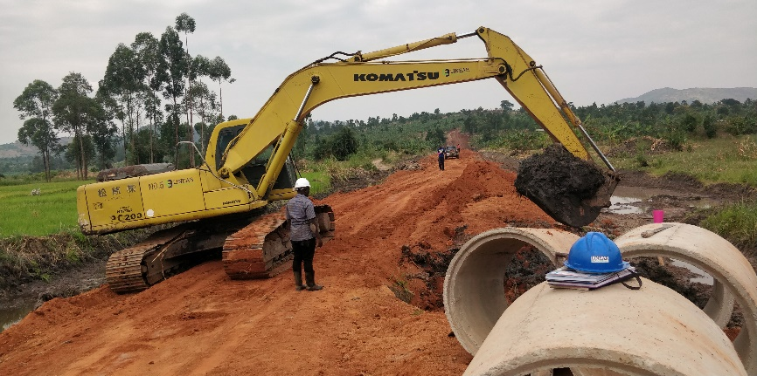
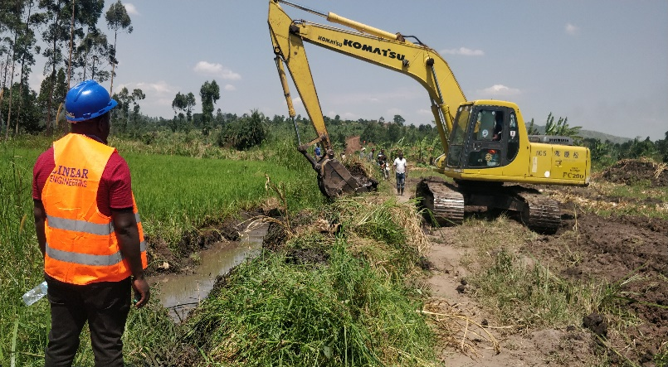
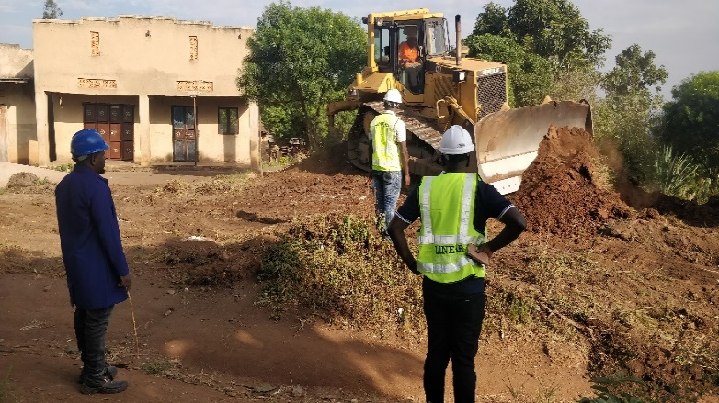

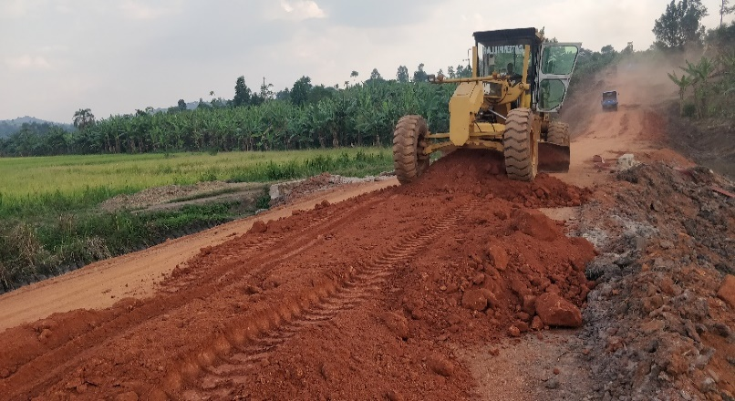
Culvert installation

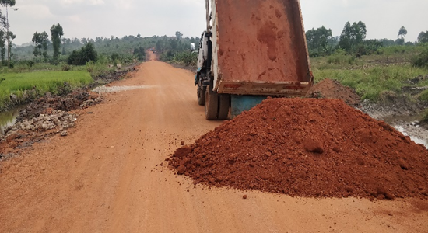

Murram dumping and spreading

Completed road works

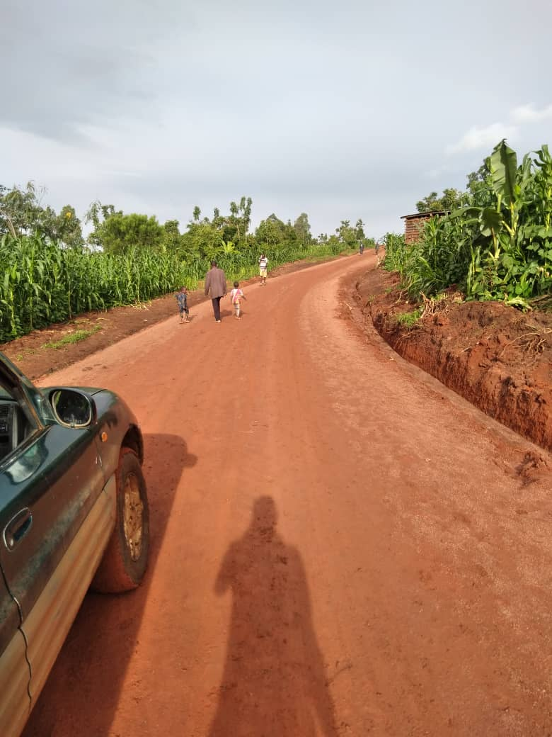



Rehabilitation of Community Access Roads in Mukono District (11.15Km)

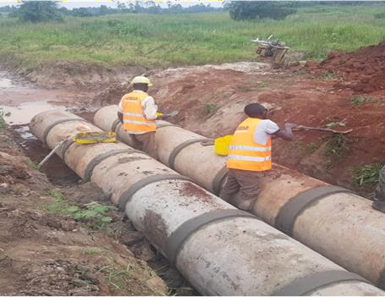
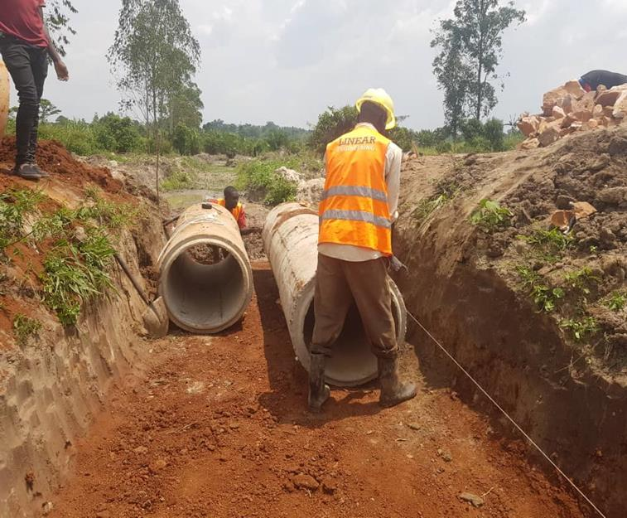

Culvert installation

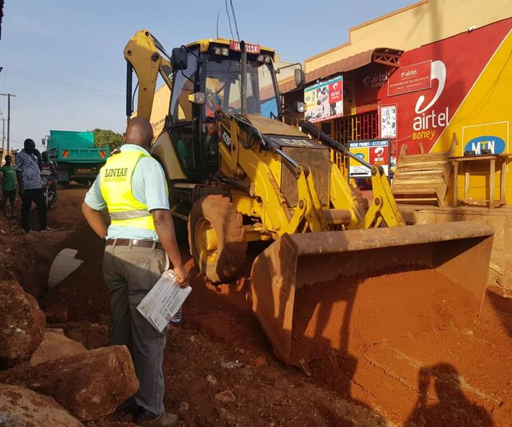
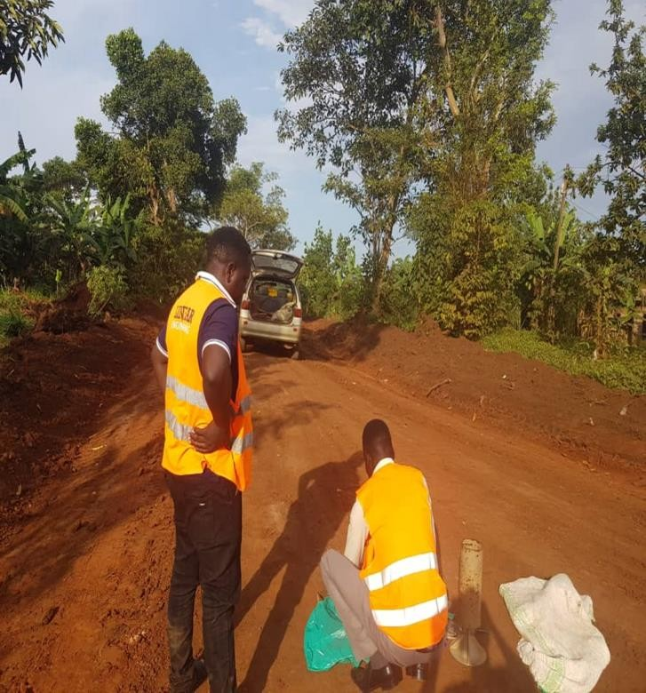

Road compaction tests Works in progress

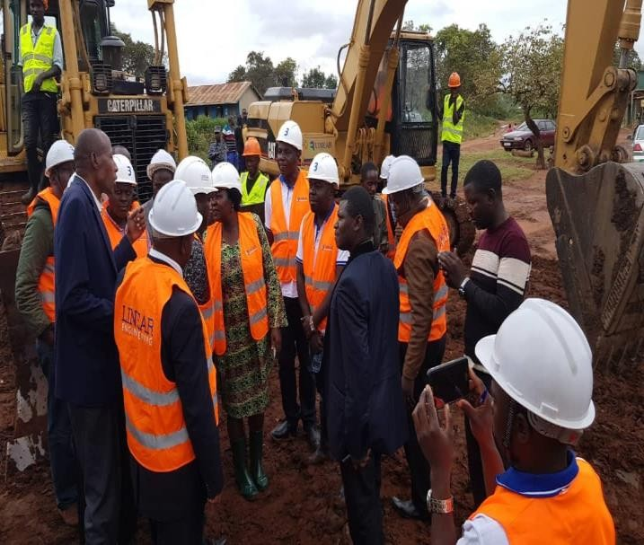
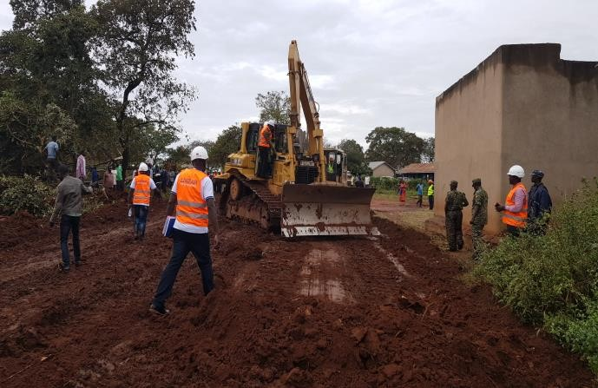
Construction of Nyamiringa –Budimbo Road (11.8km) in Kiboga District.

Ground breaking ceremony
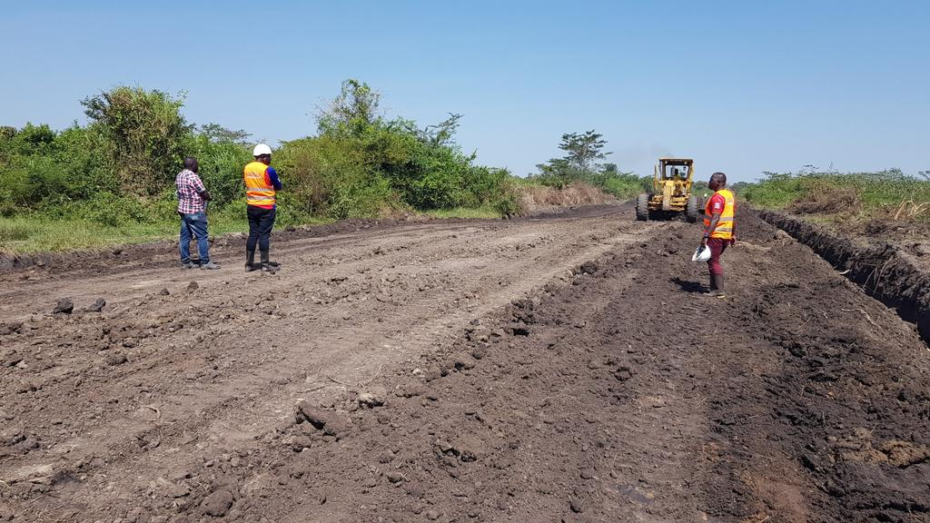
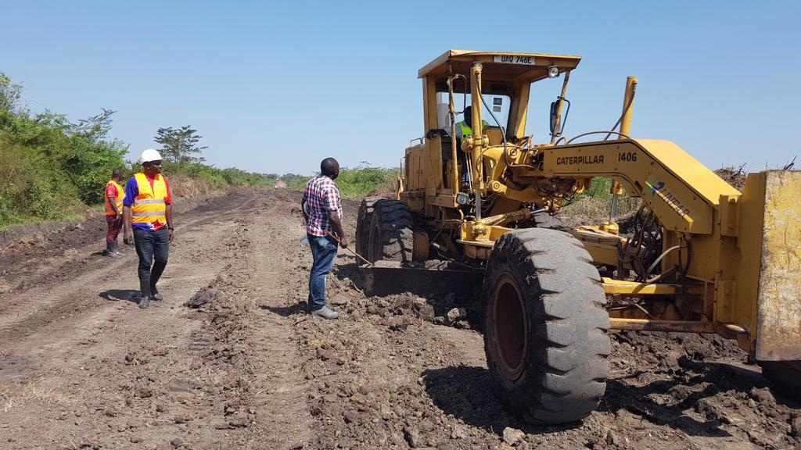

Works in progress
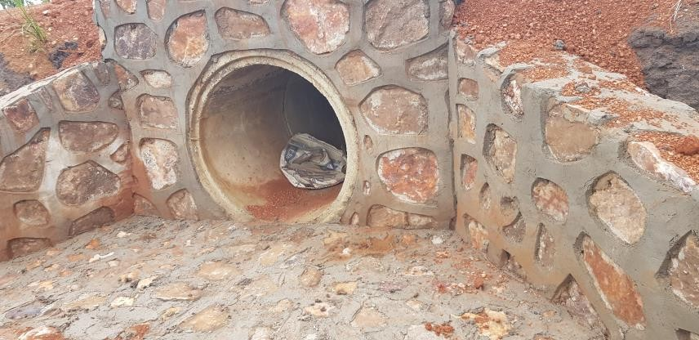
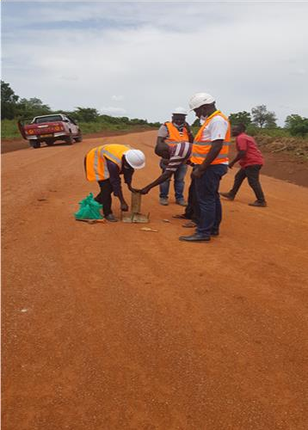
Compaction tests Installed culverts

